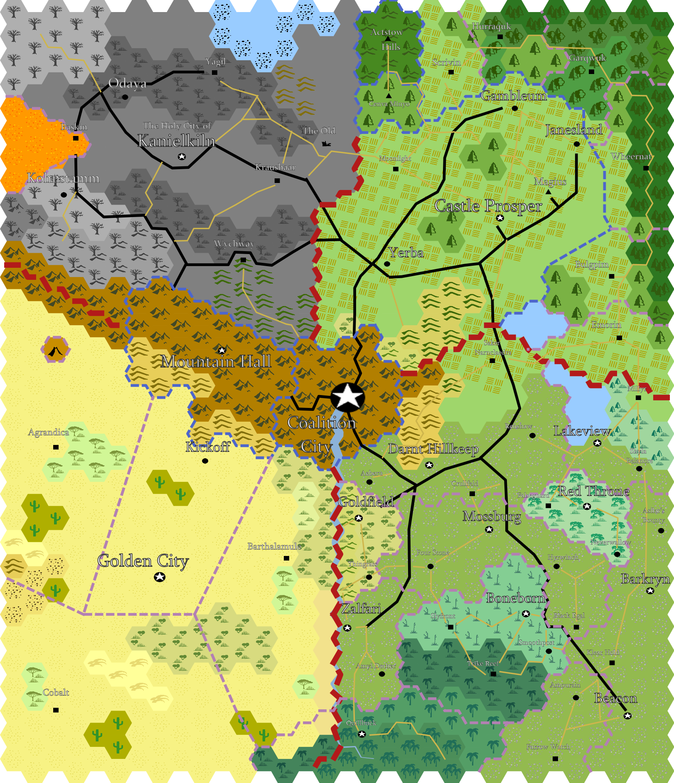
A Player's Guide to Alaturmen (v.03)
A setting-based hack of 5e D&D

Alaturmen c. 105AF
Part 0:
A Preface and/or an Introduction

I live in a place of many Wonders. The lands shift before our eyes rather than behind our backs. I doubt you would believe it nearly as beautiful as our beach, but I believe this to be the truth. There are others here, the goblins as you said, but others too! It has been truly wonderful. I hope to return to you soon.
- Eladrithal Greystone to his parents in the Feywild

Welcome to Alaturmen. This is a fantasy world, and it’s accompanying “house rules” or “hacks” that I wrote for the purposes of setting a specific tone. I am a white, non-binary author, and I have tried to incorporate the classic elements of fantasy role-playing as I see them, having grown up on younger (and noticeably shittier) editions of the game, as well as my modern perspective. I'm trying to build this shiny new fantasy setting, using Dungeons and Dragons as a huge mechanical and creative touchstone, with the intention of extracting the racism, sexism, gendered bullshit, etc. and dumping it out the window of the moving car that is modern table-top role-playing to the best of my ability as I write these stories.

Alaturmen, as currently written, is about 36,000 square miles in area. It’s culture is based around a collection of four nations, their community-centralizing "federal"-esq government, and many other smaller nation-states. I am inspired by the acts of real humans of history, a numerous number of sprinkles from fantasies & readings of my life, and finally, multiple fantasy (& sci-fi!) properties.

When I play TTRPGs I want to write the story of the adventurers who saved the world. Maybe no-one knows, and maybe there is no fame or reward; but maybe they are heralded by children as house gods. These stories usually starts small – that one healing potion is the difference between life and death. As the story picks up, and your characters get larger, stronger, more influential, it becomes more about these people, who they are, what they do, and why they do it that way.

I present to you some central truths:
1. Alaturmen is young, only a century and some change.
2. The Gods are here, we can see them walk among us. We form them with our Faith.
3. This place changes. Someone always does something that makes it change. It changes alone too.
4. The Planes are close. We can harness this, for our own power, but this poses a threat to us as well.
5. People of this place are alien to you and I, but not to each other. Some people have certain traits that we may consider incredibly abnormal, but the people of Alaturmen would not. Play your character.
6. We begin with peace; war happens anyways.
7. Things happen despite your influence. This isn't just your story.
8. If it’s yours, you may know more about it than I do. Don’t be afraid to speak truth in this world of fantasy.

Safety Tools

Lines and Veils
I will always do my best to read the room, but let it be known, I believe that no human can be a bastion of true insight or perfection. To that purpose, I am writing this here, in the Player’s Guide, as a tool for you. Please come to my game with an open mind, and I will meet you there.

You have things that you will not budge on, as do I, and as do too our other players sitting around this table. These are called Lines, and for all players at the table, including myself, no scenes involving these topics will be present in our game, and, at request, no discussions involving these topics will be present at our table.

You have things that you would not like to participate in, or see, in our game, but you are willing to participate in discussions or omashes to the topic of. As do I, and so on. These are called Veils. These are those topics we will never directly view, though we may or may not view the effects of their occurrence in the background of our fiction.

The X Card
While this may, or may not, be a physical card, with a big ol’ X on it, the idea is whats important. Throughout the game, if for literally any reason, you have the power to grab my attention, and then no questions asked, stop the scene through me, at a moment’s gesture. We should decide, during our first or zeroth session, what The X Card will be for us.

Part 1:

Building a Character
To build a character that fits into this world, I humbly request that you work with me to merge the mechanical necessities with our story-telling wishes. A part of this for me is taking what Wizards of the Coast says about what is true and tweaking it. A lot. Some call it hacking, or house-rules, I call it the Truth in Alaturmen, as the Fates have Woven. I don’t really, but like, that’s what it is.

Much like in real life, the concept of "race" is a false creation on Alaturmen and its surrounding planes. The mechanical benefits that the Player's Handbook explicitly assigns to race sucks! I am following in the footsteps of "Ancestry and Culture; An Alternative to Race in 5e" produced by Arcanist Press and splitting those mechanical benefits between your character's Culture and their Heritage.

Your character will inherit certain traits from their heritage, such as their size and speed, and will be affected by their culture by a cultural alignment and ideals (in the form of Ability Score Increases and the like).

In addition, many mechanics of the typical 5th edition experience have changed, slightly, or drastically, depending on your taste.

In addition to selecting an originating Culture and Heritage, you will select an Ex-Occupation, how you maintained yourself in this place before you became who you are now, and your newest form of identity & ability – your Class.

The following material is nearly all somewhat tweaked or customized, and the whole of this document cannot be captured in a single version of it’s existence. In any case, much of the following should be familiar to you, and subject to change.

Heritages
Some heritages are marked with an (s.) or an (a.). This corresponds to the ability for this heritage to participate in sexual reproduction (s.) or not (a.). Those heritages that are capable of sexual reproduction are compatible for the purposes of conceiving a child.

If you question the necessity of this information, I commend you, usually, this kinda shit is gross as fuck and very fetishistic in a very bad way. I mark this with the intention of informing you of some setting specific details of these fantasy people. I'm trying to be cool; this is meant to be much, much more "hey look at these cool aliens I thought up" than "these people are bad, weird and do/don't fuck" because let's be very clear – that’s personal, and usually a soft veil during my games.

Common to Alaturmen
The following heritages are commonly found throughout Alaturmen. I recommend selecting from this section for your first experience in this plane. An “average” commoner likey is of one of these heritages.

Goblin (s.)
Goblin are small, gangly humanoid with sharp ears and quick wits. Goblin share their origin myth with the Hobgoblin and Bugbear; the Titan Demogorgon created the Goblin-oid without purpose, keeping them as pawns and pets. They escaped Demogorgon's influence into the greater multiverse before many of the Planes of the Multiverse were reality.
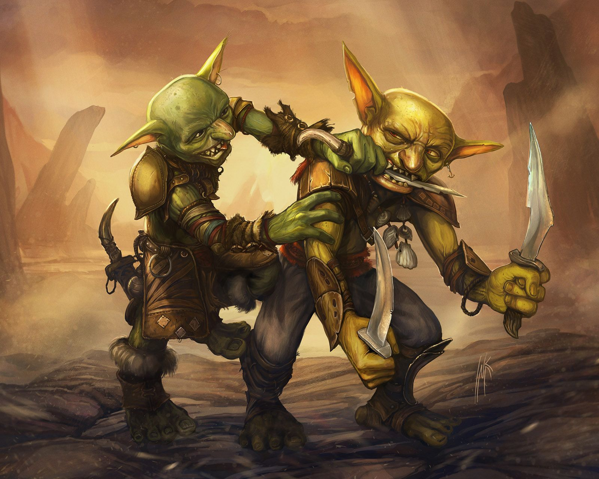
Age. You are considered fully matured at age thirteen and live to be about thirty-five. Goblin mothers birth litters of about six children.
Size. Mechanically, you are considered a small creature. You stand at about three and a half feet tall, though your limbs are built for someone just an inch or two taller than yourself. You weigh about eighty pounds.
Speed. Your speed is 30 feet per round.
Small Form. You can move through the space of any creature that is of a size larger than yours. You can attempt to hide even when you are only obscured by a creature that is at least one size larger than you.
Fury of the Small. When you damage a creature of a size category larger than yours with an attack or a spell, you may cause the damage to be increased by an amount of extra untyped damage equal to your level. Once you activate this heritage ability, it cannot be activated again until you finish a short or long rest.
Preternatural Agility. You may take the Disengage or Hide actions as a bonus action on your turn. You gain proficiency, or expertise if you already have proficiency, in both your Armor Class and Dexterity (Stealth).

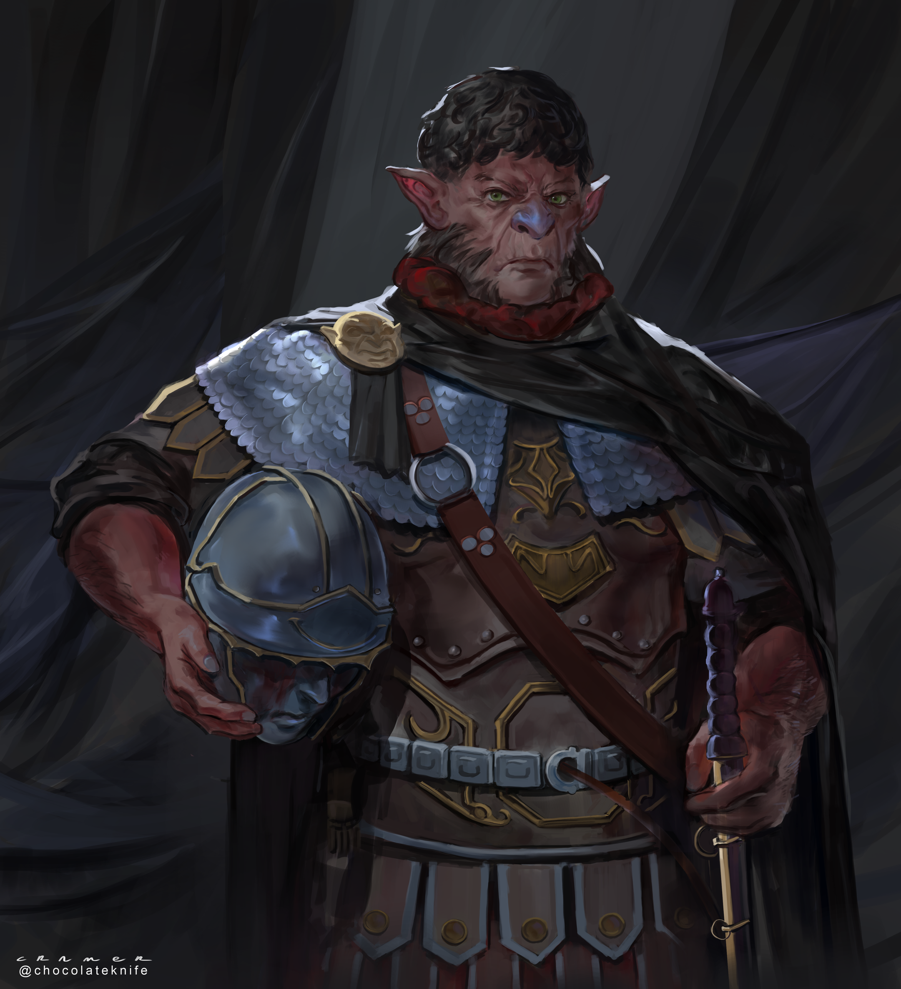
Hobgoblin (s.)
Hobgoblin are extremely similar to humans, the largest difference between the two being that the Hobgoblin know the myth of their origins.

Age. You are considered fully mature at twenty-five and live to about eighty-five. Hobgoblin mothers birth children in twins, though these children are never identical.
Size. Mechanically, your size is medium. You stand at about five and a half feet tall. You weigh about one-hundred seventy-five pounds.
Speed. Your speed is 30 feet per round.
Versatile Form. You gain proficiency in a skill of your choice. You gain one feat of your choice. You may increase one ability score of your choice by one.

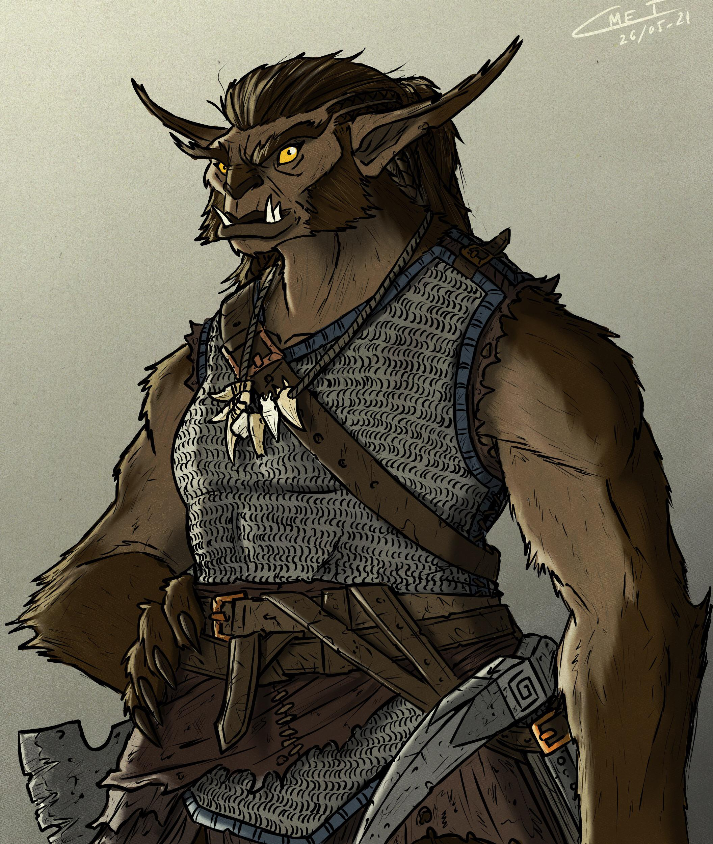
Bugbear (s.)
Bugbear are large, gangly humanoid with sharp ears and heavy fur.

Age. You are considered fully mature at sixteen and live to about fifty. Bugbear mothers birth litters of about four children.
Size. Mechanically, your size is medium. You stand at about seven and a half feet tall. You weigh about 300 pounds.
Speed. Your speed is 35 feet per round.
Long-Limb'd. Mechanically, your reach when making melee attacks is five feet longer than it "should" be. Your limbs are not five feet longer than the average seven foot human, but your gangly form allows you to maintain a larger "Area of Influence" during combat.
Powerful Form. You have proficiency in the Athletics skill. You count as one size larger when determining your carrying capacity and the weight you can push, drag, or lift.

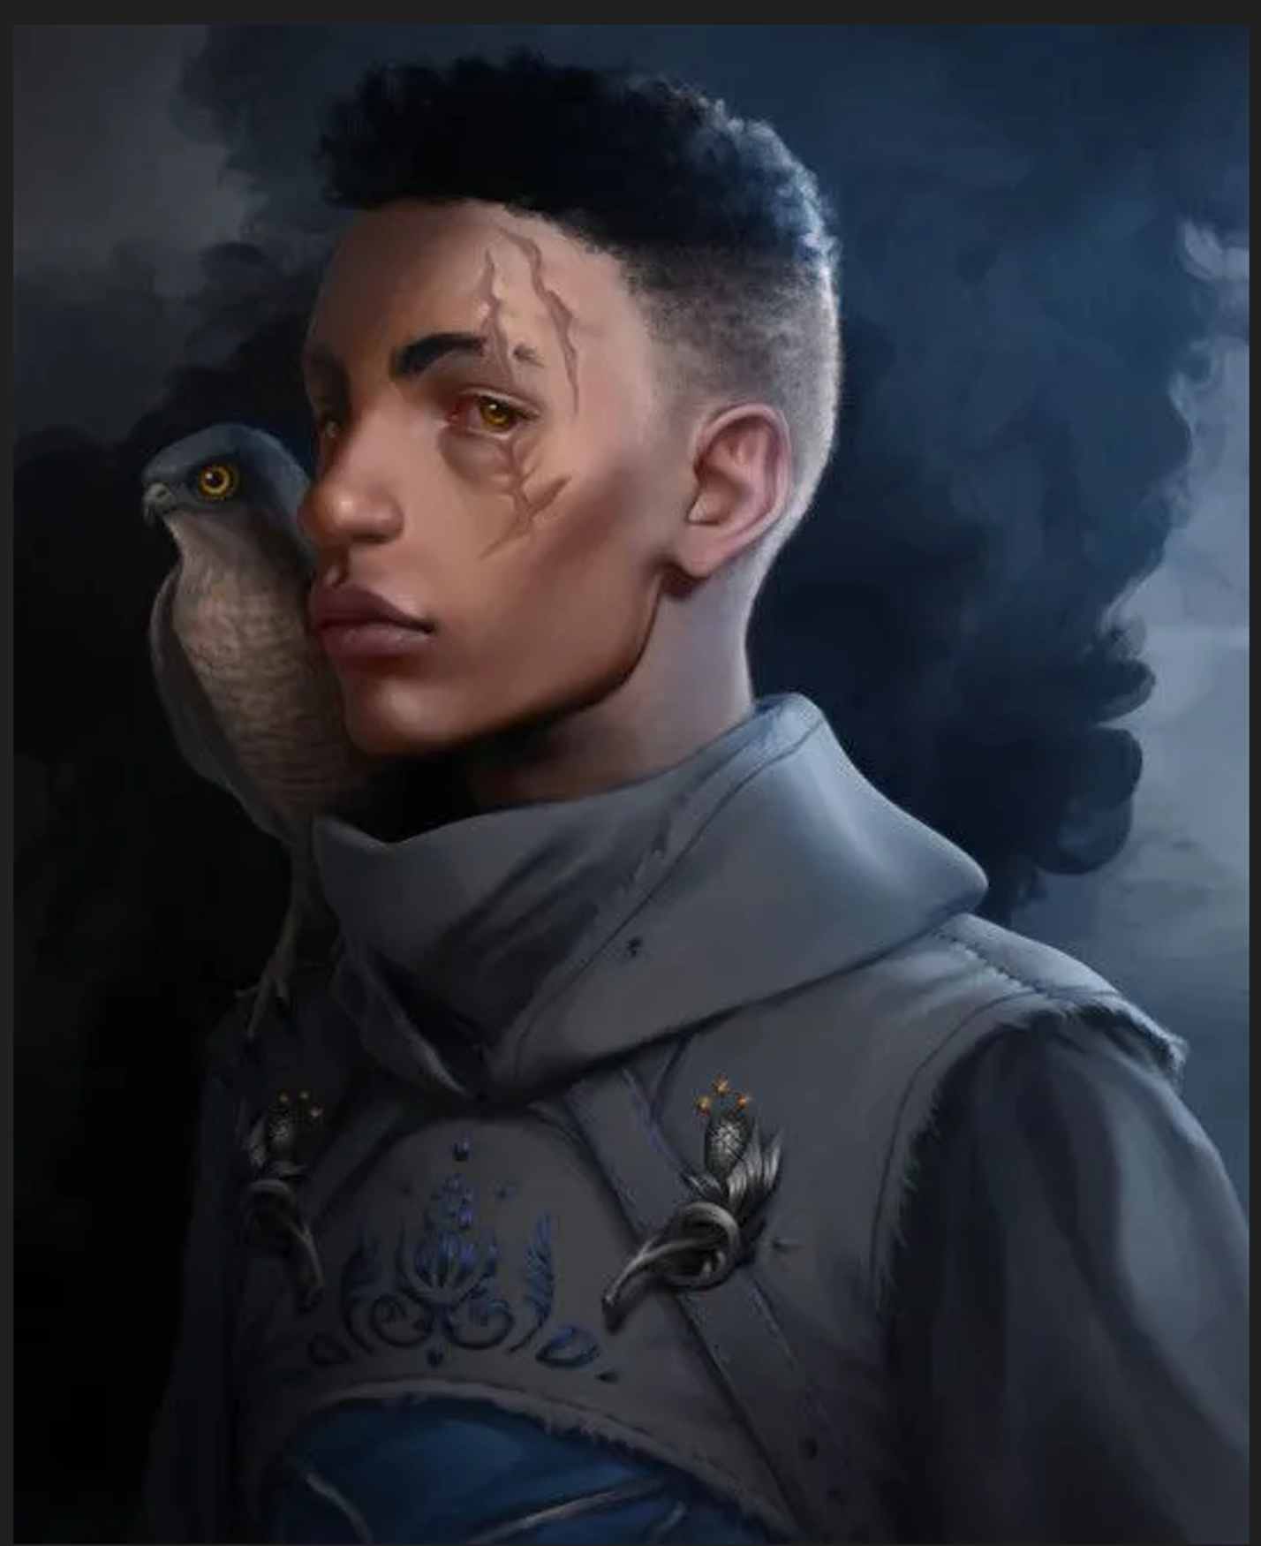
Human (s.)
The humans of Alaturmen have no creation myth of their own – the legends claim that as Time Began upon Alaturmen, the Goblin, Elves, Dragon-kin, and Triton found them bare-naked in the fields. Humans on Alaturmen are extremely similar to the Humans of Ancient Earth, much as you and I are.

Age. You are considered fully mature at twenty-five and live till about ninety. Human mothers typically birth only one child per conception, but it is possible that a human could birth quite large litters.
Size. Mechanically, your size is medium. You stand at about five and a half feet tall. You weigh about one-hundred seventy-five pounds.
Speed. Your speed is 30 feet per round.
Versatile Form. You gain proficiency in a skill of your choice. You gain one feat of your choice. You may increase one ability score of your choice by one.

Elven (s.)
Many of the visual features of an Elf is based on their seasonal ancestry, although they all share their above human-average height, sharp ears, and powerful eyes.

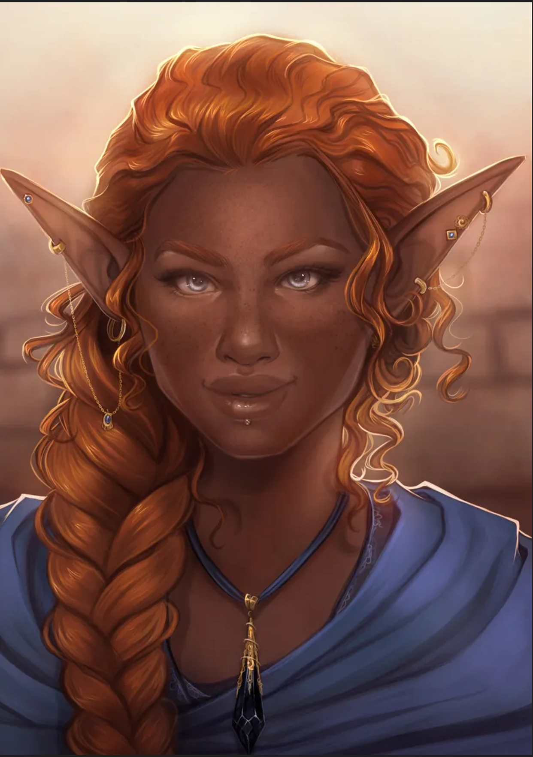
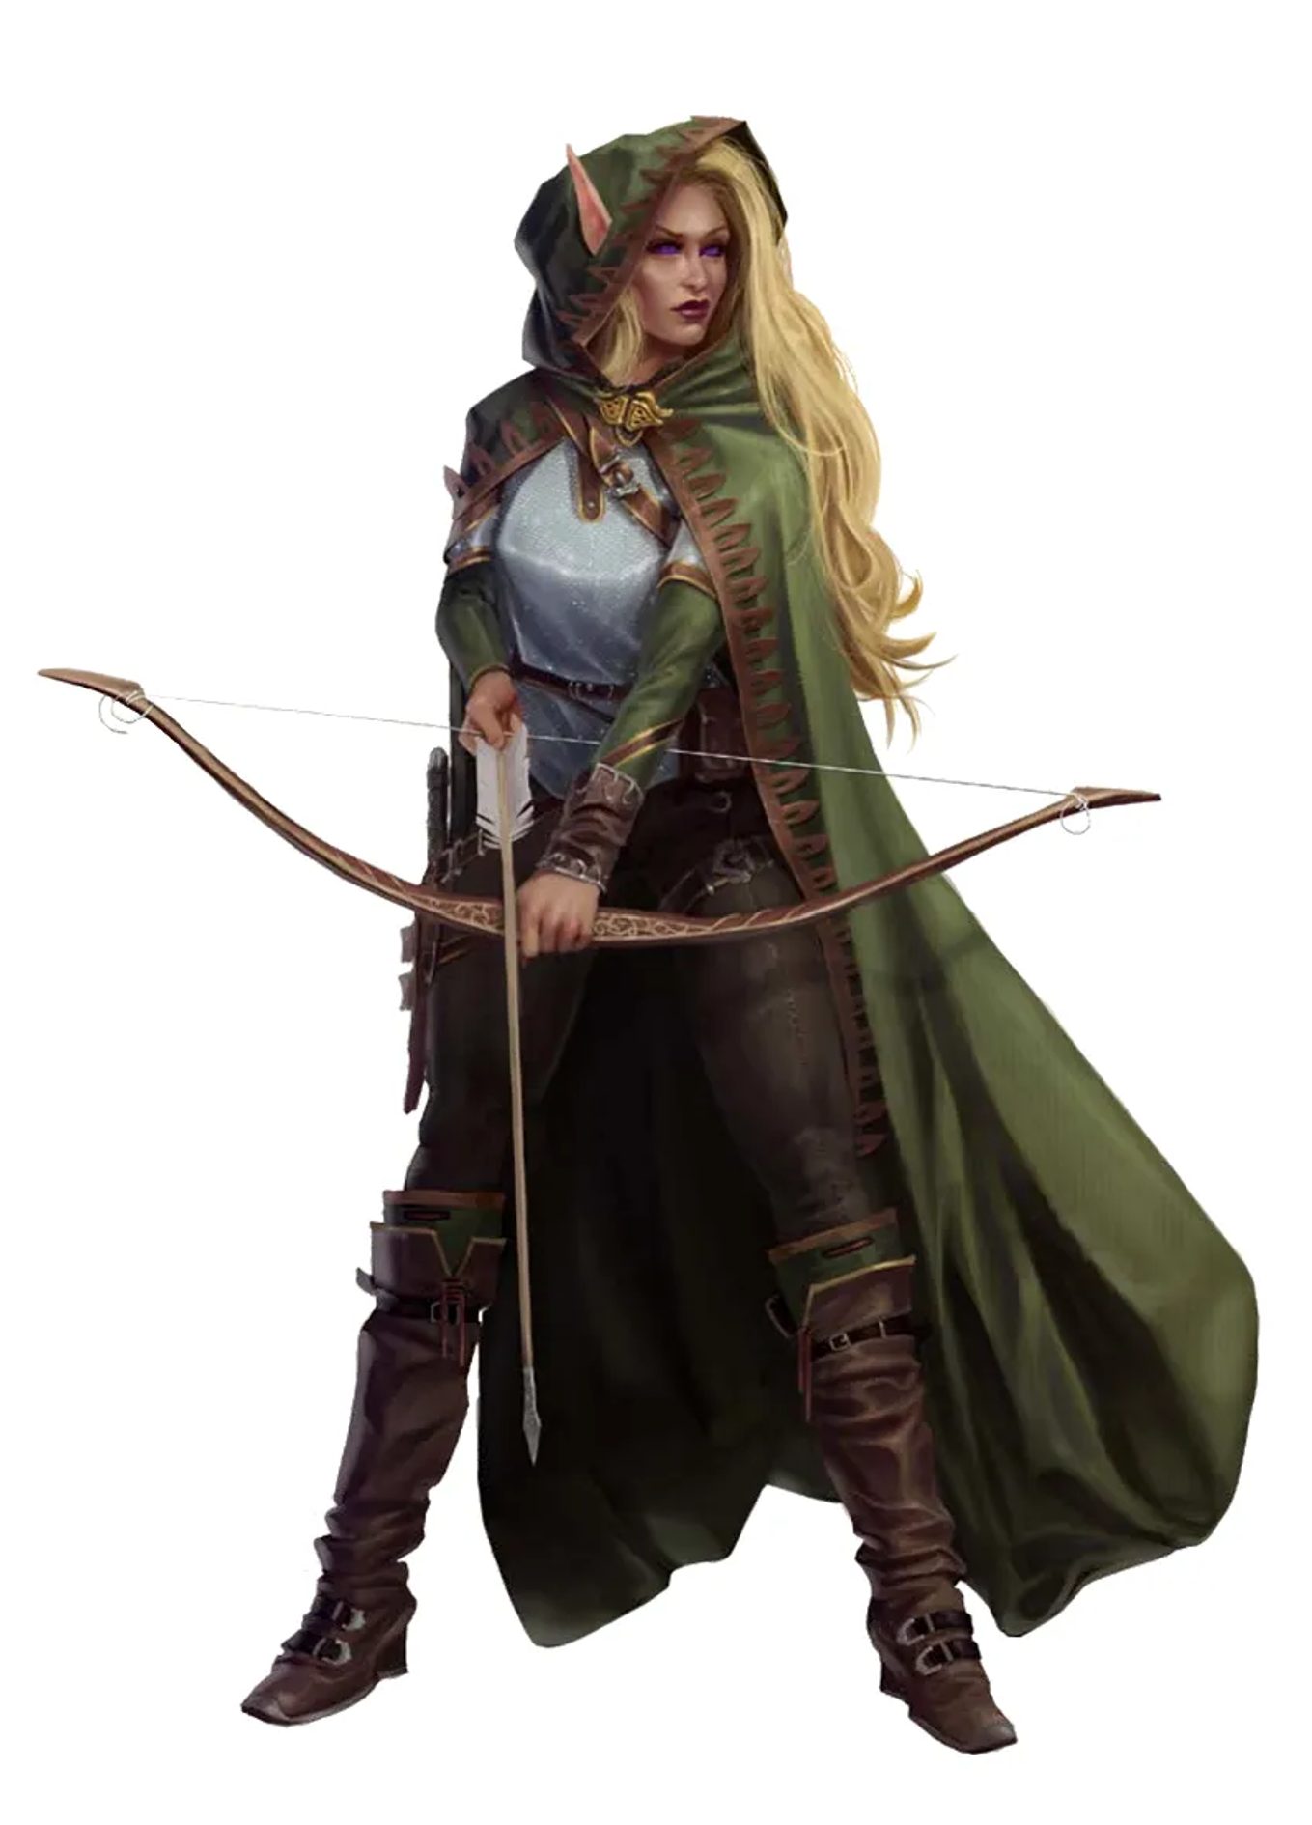
Age. Although you are considered fully mature at about twenty-five, the traditional elven perception of "adulthood" is based on experience more than chronology. As a feature of one's coming-of-age, one would change their name from that given at birth by their parents to that name they believe they have earned. As an elf reaches the end of their satisfied life, which generally happens sometime after three hundred years of life, they Walk beyond their home plane – whatever they may find. Elven parents must be integral in the full creation process of some artistic or creative work either directly before, during, or directly after the acts of conception.
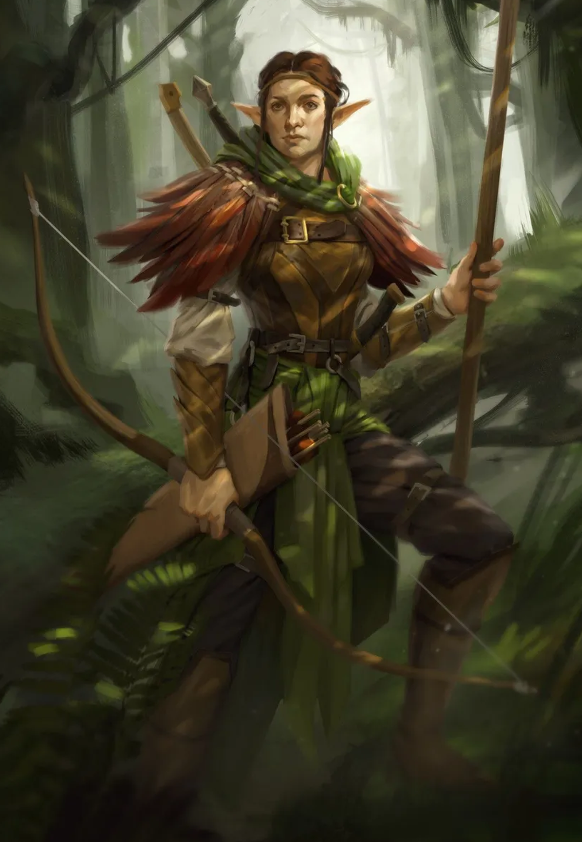
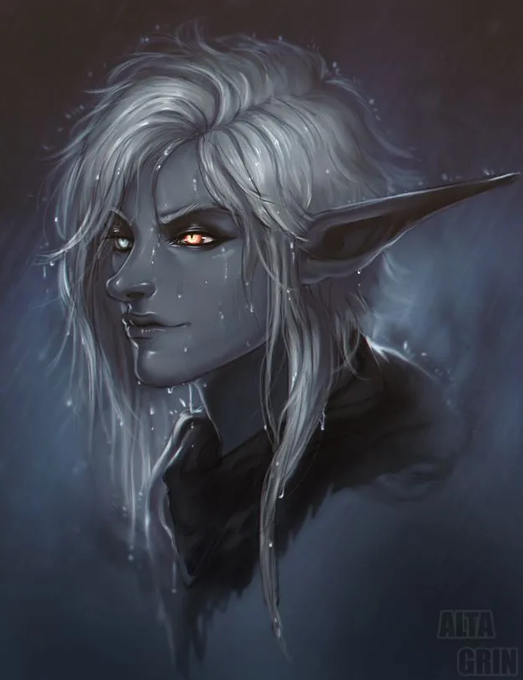
Size. Mechanically, your size is medium. You stand at about six feet tall. You weigh about one-hundred forty-five pounds.
Speed. Your speed is 30 feet per round.
Trance. You do not sleep. Instead you meditate deeply, remaining semi-conscious, for 4 hours a day. While meditating, you dream after a fashion; but such dreams are truly mental exercises you have developed and over time have become reflexive after your years of practice. After resting in this way, you gain the same benefit a human would from 8 hours of sleep.
Keen Senses. You have advantage on Wisdom (Spot) checks (The online dice service anydice.com tells me that this translates in to a mean increase of 3.82 over the 10 traditionally used for passive-style checks. Call it plus 4.).
Fey-Ceilie Ancestry. You have advantage on saving throws against effects that charm and you cannot be made to sleep by magical means. You also gain another trait as corresponding to your seasonal ancestry;
- Spring. Your base walking speed increases to 35 feet, and you have advantage on saving throws that apply Exhaustion.
- Summer. You gain resistance to fire damage, experience extreme heat as only mild heat, and you have advantage on advantage on saving throws that apply Exhaustion.
- Autumn. You can attempt to hide even when you are only lightly obscured by foliage, heavy rain, falling snow, mist, and other natural phenomena. If you are not proficient in Dexterity (Stealth), you may make such a check as though you had proficiency, and if you do have proficiency, you may roll such a check with advantage.
- Winter. You have disadvantage on attack rolls and Wisdom (Spot) checks that rely on sight when you, the target of the attack, or whatever you are trying to perceive is in direct sunlight. You know the Dancing Lights cantrip. When you reach 3rd level, you can cast the Faerie Fire spell once with this trait and regain the ability to do so when you finish a long rest. When you reach 5th level, you can cast the Darkness spell once and regain the ability to do so when you finish a long rest. Charisma is your spellcasting ability for these spells.

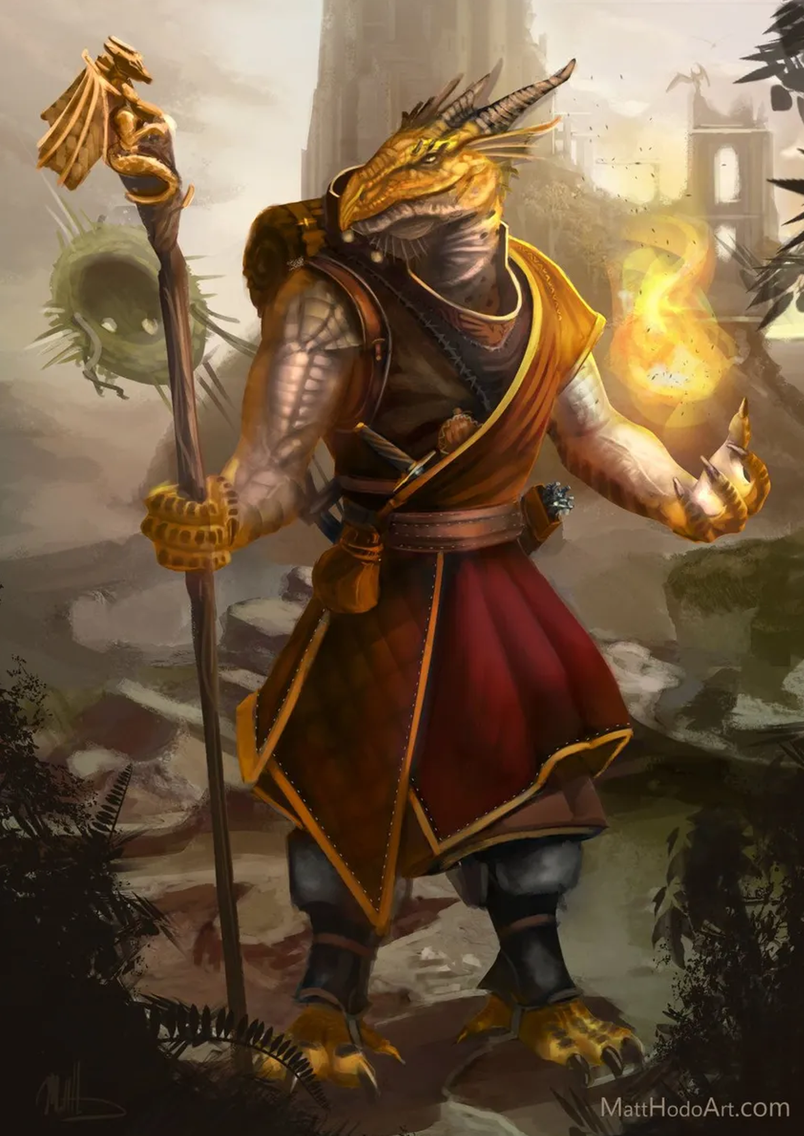
Dragonborn (s.)
Common wisdom tells us that the Dragonborn were quite literally born to a humanoid and a dragon, inheriting their color of scale and affinity of element from their dragon ancestors.

Age. You are considered fully mature at age twenty-five and live till about one-hundred thirty. Dragonborn mothers typically birth only one child per conception, but it is possible that a mother could birth quite large litters. Dragonborn parents pass their Draconic Ancestry on to their children. When two dragonborn parents are directly responsible for conceiving children, the children are near-randomly assigned one ancestry over another.
Size. Mechanically, you are considered Medium. You stand about six feet tall. You weigh about 240 pounds.
Speed. Your speed is 30 feet per round.
Draconic Ancestry. You are distantly related to a particular kind of dragon. Choose a type of dragon from the below list; this determines the damage and area of your breath weapon, and the type of resistance you gain.
- Breath Weapon. You can use your action to exhale destructive energy. It deals damage in your choice of a 15' cone or a 30' line. When you use your breath weapon, all creatures in the area must make a saving throw, the type of which is determined by your draconic ancestry. The DC of this saving throw is 8 + your Constitution modifier + your proficiency bonus. A creature takes 2d8 damage on a failed save, and half as much damage on a successful one. The damage increase to 3d8 at 6th level, 4d8 at 11th, and 5d8 at 16th level. After using your breath weapon, you cannot use it again until you complete a short or long rest.
- Chromatic Warding. Starting at 3rd level, as an action, you can channel your draconic energies to protect yourself. For 10 minutes, you become immune to the damage type associated with your Chromatic Ancestry. Once you use this trait, you can’t do so again until you finish a long rest.

Draconic Ancestry | Type
Black | Acid
Blue | Lightning
Green | Poison
Red | Fire
White | Cold
Yellow | Force
Brass | Fire
Bronze | Lightning
Copper | Acid
Gold | Fire
Silver | Cold

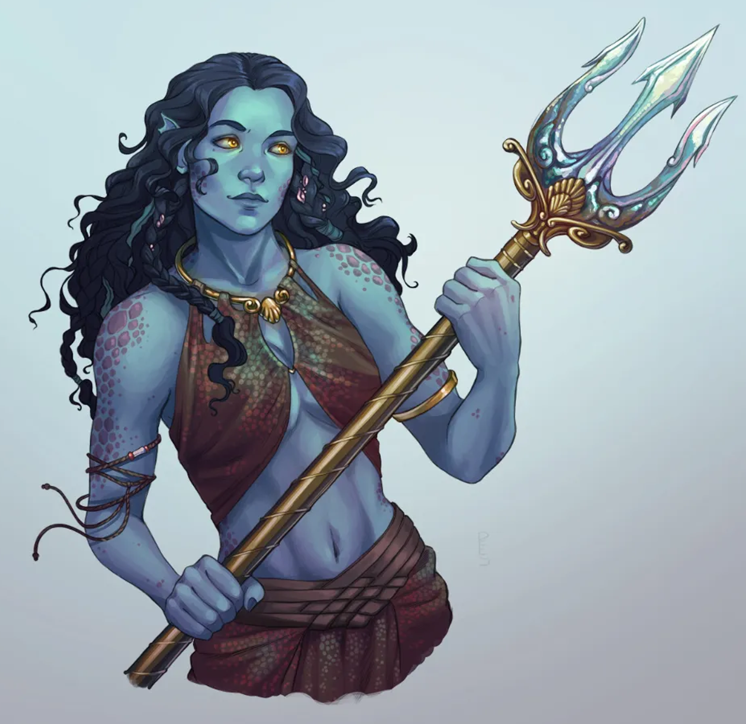
Triton (s.)
The Triton swam from the Plane of Water into Alaturmen. Why or how is largely unknown, but it is the truth that they came to Alaturmen when the elves and humans did.

Age. You are considered fully mature at twenty and live to over two hundred. Triton mothers typically birth only one child per conception, but it is possible that a mother could birth quite large litters.
Size. Mechanically, your size is Medium. You stand at about five feet tall. You weigh about 160 pounds.
Speed. Your speed is 30 feet per round. You gain a swimming speed of 25 feet per round.
Amphibious. You can breathe air and water.
Elemental Ancestry (Water). Adapted to even the most extreme ocean depths, you have resistance to cold damage. Aquatic beasts have an extraordinary affinity with your people. You can communicate simple ideas with beasts that can breathe water. They can understand the meaning of your words, though you have no special ability to understand them in return. You know one cantrip shape water.

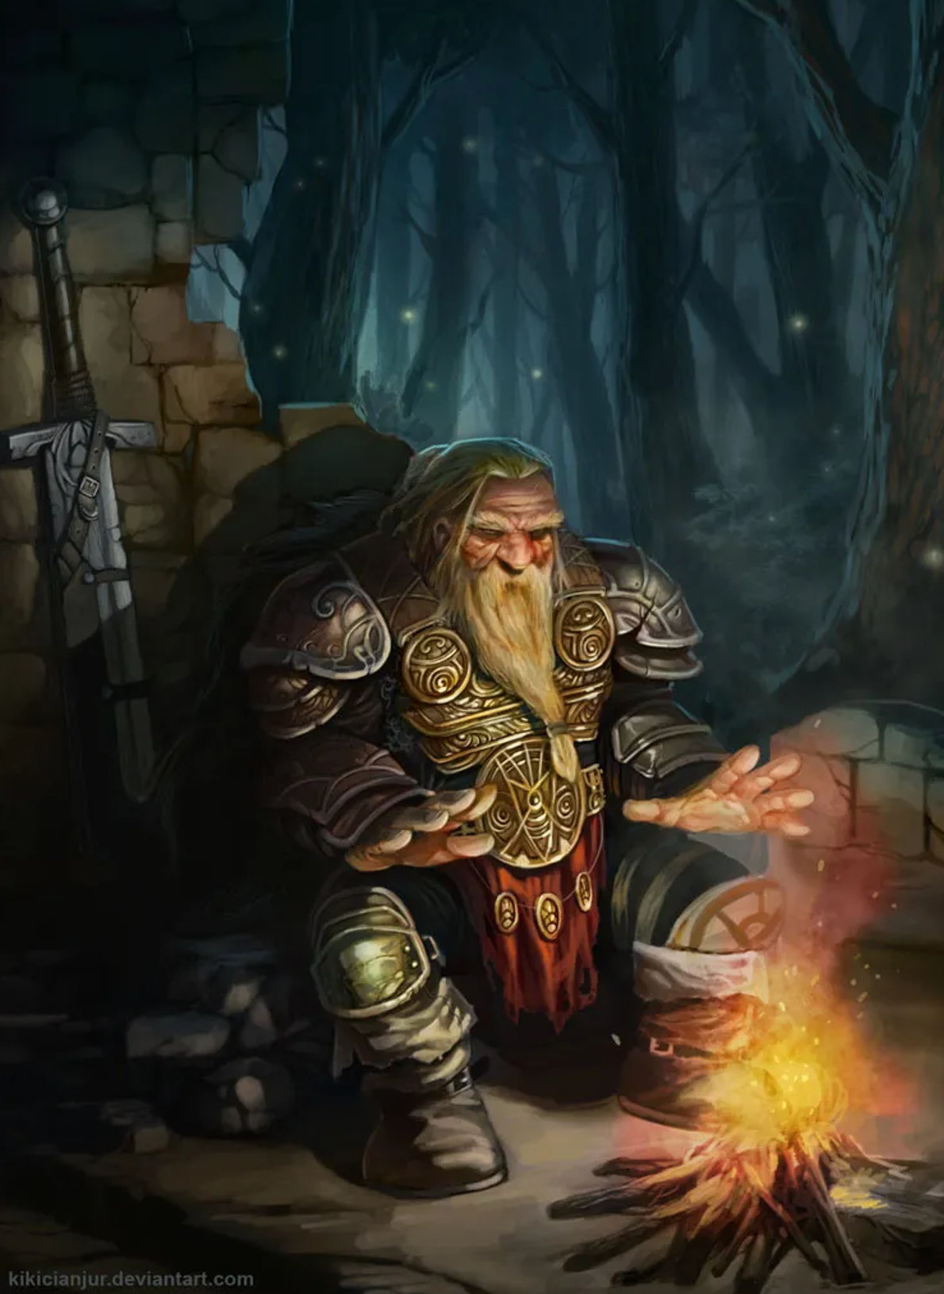
Dwarven (a.)
The origins of dwarves are shrouded in myth, with some saying that their ancestors were fashioned from the very stone itself.

Age. You are considered fully mature at twenty-five, and live until about two-hundred twenty. Dwarves reproduce ritually, in groups of two or more, and carve their children of stone, metal, and fine gem. Due to the process of carving a child, a parent will usually spend three months participating in this ritual, and will produce one child per participant. This gives dwarves no reason to participate in gender, though they often have gender forced upon them in alien cultures.
Size. Mechanically, your size is Medium. You stand at four and a half feet tall. You weigh about 230 pounds.
Speed. Your speed is twenty-five feet per round.
Darkvision. You can see in dim light within 60 feet of you as if it were bright light, and in darkness as if it were dim light. You can't discern color in darkness, only shades of gray.
Elemental Ancestry (Earth). You have advantage on saving throws against poison, and you have resistance against poison damage. Whenever you make an Intelligence (History) check related to the origin of stonework, you are considered proficient in the History skill and add double your proficiency bonus to the check, instead of your normal proficiency bonus. Your hit point maximum increases by 1, and it increases by 1 every time you gain a level.

Uncommon to Alaturmen
The following heritages are not commonly found throughout Alaturmen. I recommend selecting from this section after your first exploration into Alaturmen, as these heritages have certain quirks that greatly effect element’s of a character’s story. An “average” commoner likely has heard of, if not actually seen, a character of one of these heritages.

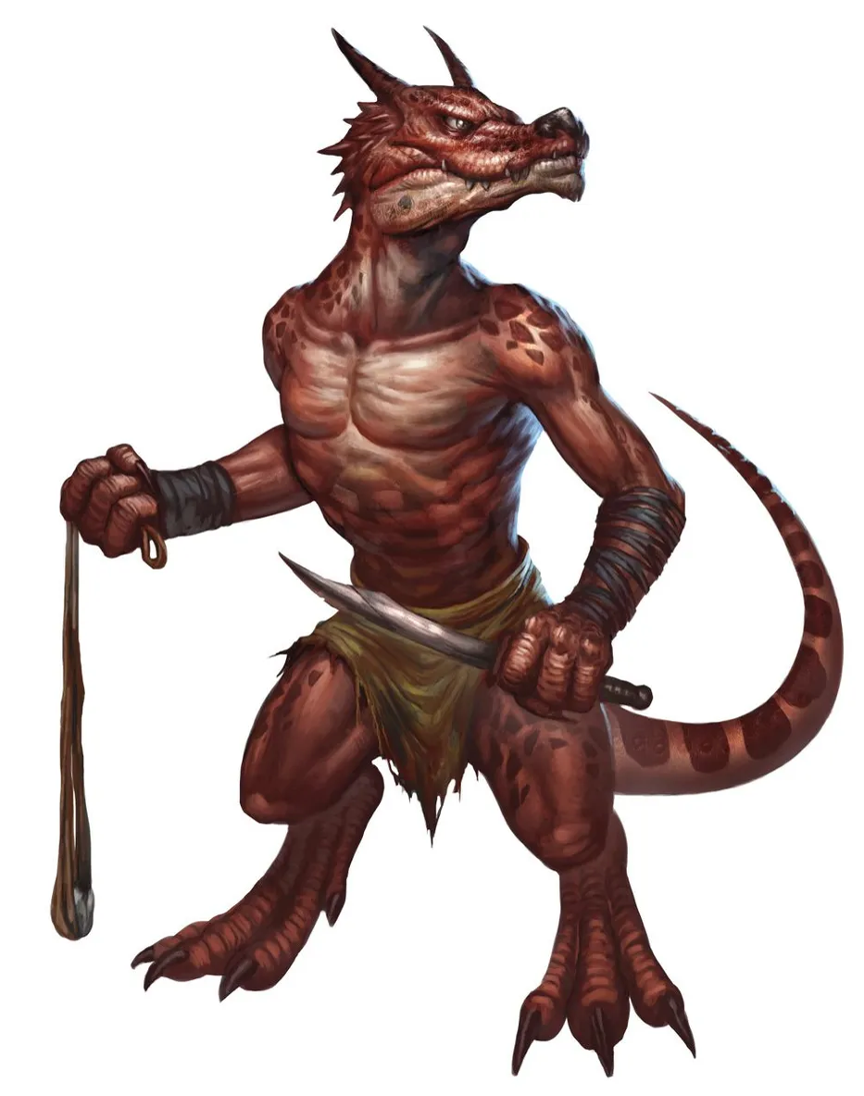
Kobold (a.)
Kobolds are rumored to be formed from the blood of a true Dragon, and inherit a measure of that dragon's powers.

Age. You are considered fully mature at age six and you can live up to one-hundred and twenty years. Kobold mothers birth litters of about six.
Size. Mechanically, your size is small. You stand at about two and a half feet tall. You weigh about sixty pounds.
Speed. Your speed is 30 feet per round.
Darkvision. You can see in dim light within 60 feet of you as if it were bright light, and in darkness as if it were dim light. You can't discern color in darkness, only shades of gray.
Pack Brain. You have advantage on an attack roll against a creature if at least one of your allies is within 5 feet of the creature and the ally isn't incapacitated.
Sunlight Sensitivity. You have disadvantage on attack rolls and on Wisdom (Spot) checks that rely on sight when you, the target of your attack, or whatever you are trying to perceive is in direct sunlight.
Blood of Dragon. You have advantage on saving throws to avoid or end the frightened condition on yourself. You know one cantrip of your choice from the sorcerer spell list. Intelligence, Wisdom, or Charisma is your spellcasting ability for that cantrip).

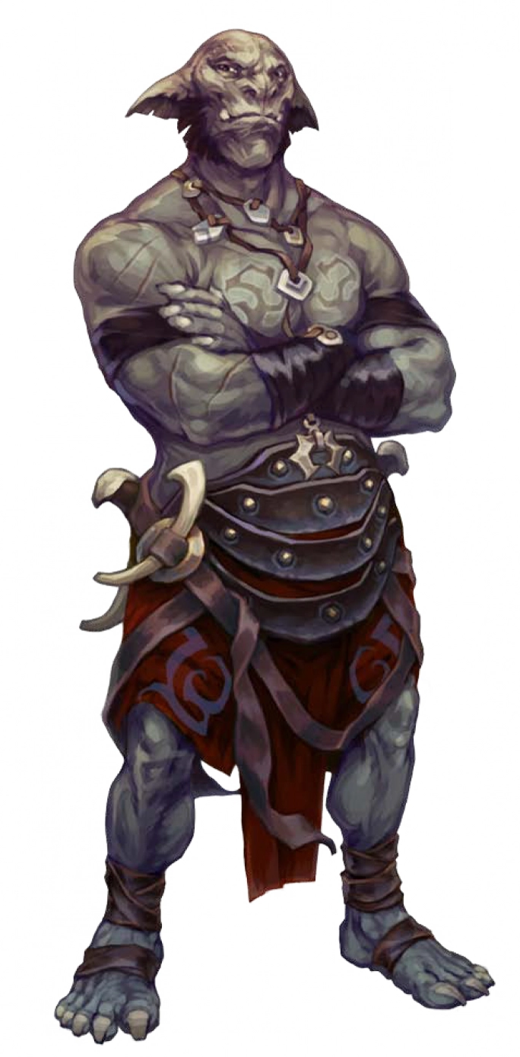
Orc (a.)
Orcs have been the slave-race of the multiverse for as long as they have existed, the Titans created them for this purpose. Orcs on Alaturmen are young, descendants of those survivors of The Assault of the Giant Dissenters.

Age. You are considered fully mature at fourteen and live to be about seventy. Orcs reproduce ritually, with a mage imparting Woven life into the severed flesh of any number of Orc.
Size. Mechanically, your size is Medium. You stand at about six and a half feet tall. You weigh about 260 pounds.
Speed. Your speed is thirty feet per round.
Unrelenting Endurance. When you are reduced to 0 hit points but not killed outright, you can drop to 1 hit point instead. You can’t use this feature again until you finish a long rest.
Powerful Build. You count as one size larger when determining your carrying capacity and the weight you can push, drag, or lift.

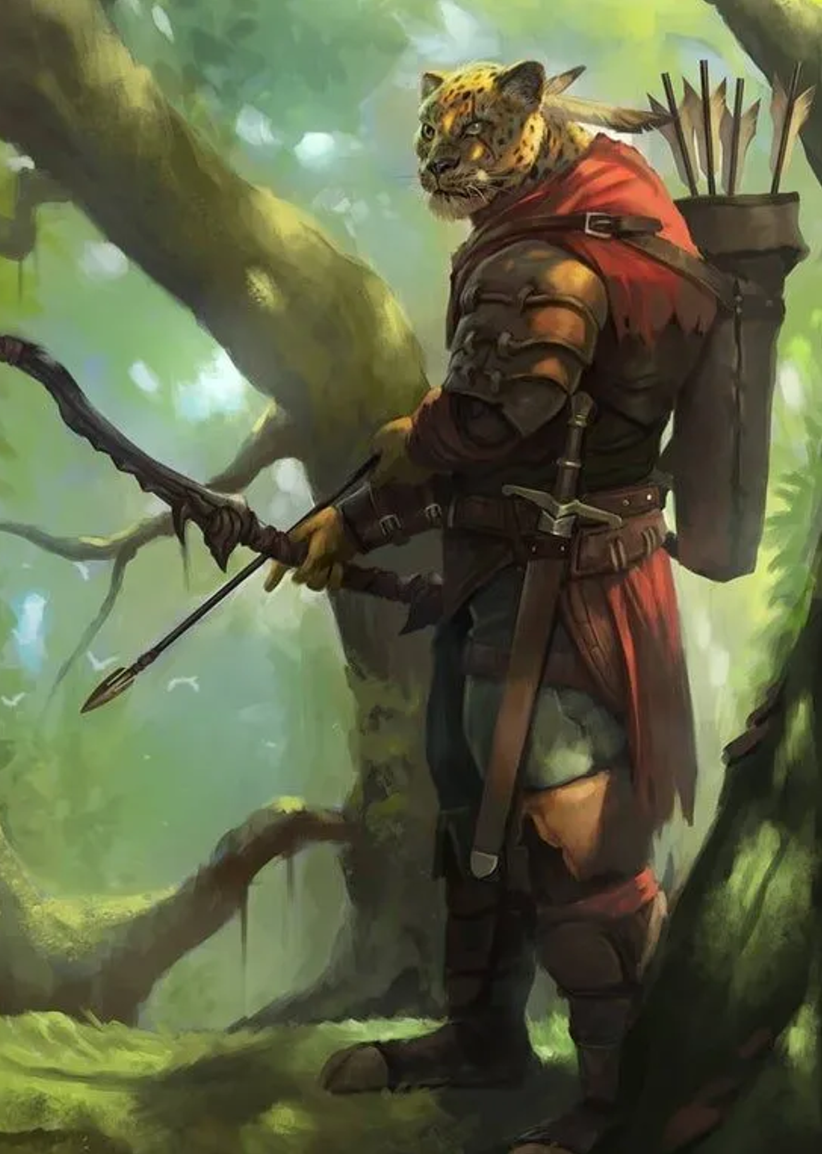
Tabaxi (s.)
The Tabaxi have become on Alaturmen only recently, born to the Beasts Righteous of the Great Quillbuck Jungle.

Age. You are considered fully mature at about twenty-two and live to about ninety. Tabaxi mothers typically birth litters of about three children.
Size. Mechanically, your size is Medium. You stand at about four and a half feet tall. You weigh about one-hundred pounds.
Speed. Your speed is thirty-five feet per round.
Lesser Darkvision. You can see in dim light within 45 feet of you as if it were bright light, and in darkness as if it were dim light. You can't discern color in darkness, only shades of gray.
Natural Claws. You are proficient with a Claw attack, which is a melee weapon attack that deals 1d4 piercing damage plus your Dexterity modifier. This Claw attack can replace any number of your weapon attacks when performing a Multiattack action or an Opportunity Attack reaction.

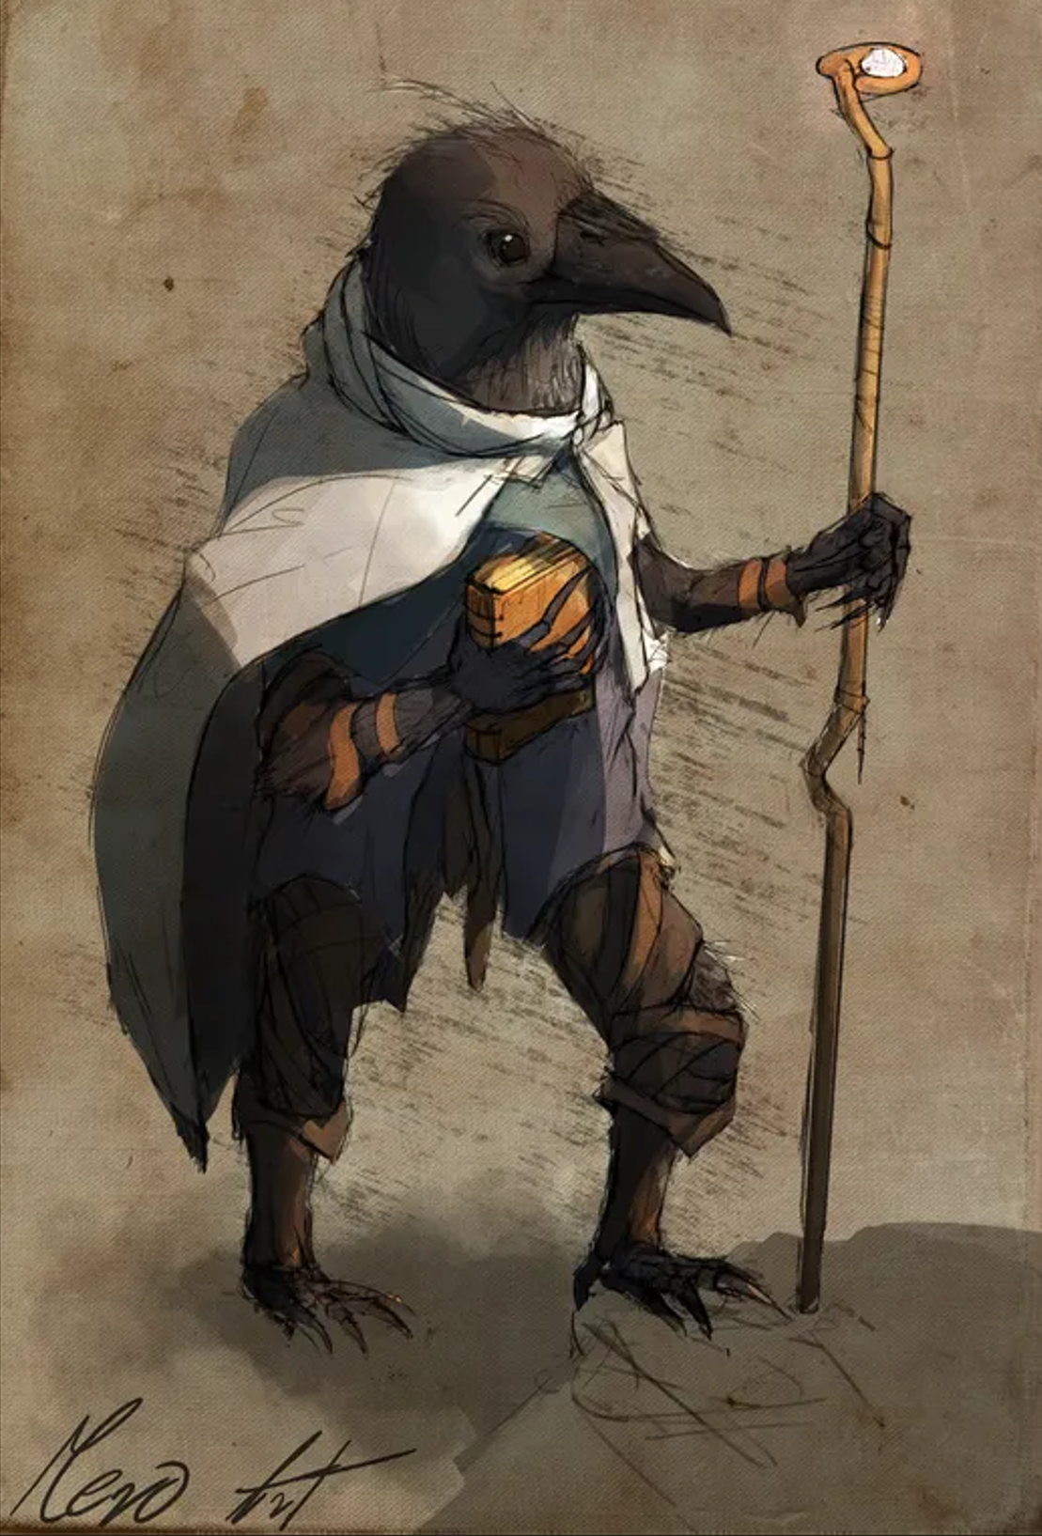
Kenku (s.)
The Kenku have become on Alaturmen only recently, born to the Beasts Righteous of the Great Quillbuck Jungle.

Age. You are considered fully mature at twelve and you live until about sixty.
Size. Mechanically, your size is Small. You stand at two and a half feet tall. You weigh about fifty pounds.
Speed. Your speed is 30 feet per round. You gain a hovering speed of 5 feet per round.
Mimicry. You can precisely mimic sounds, including voices, you have heard. A creature that hears the sounds you make can only tell they are imitations with a successful Wisdom (Insight) check opposed by your Charisma (Deception) check.

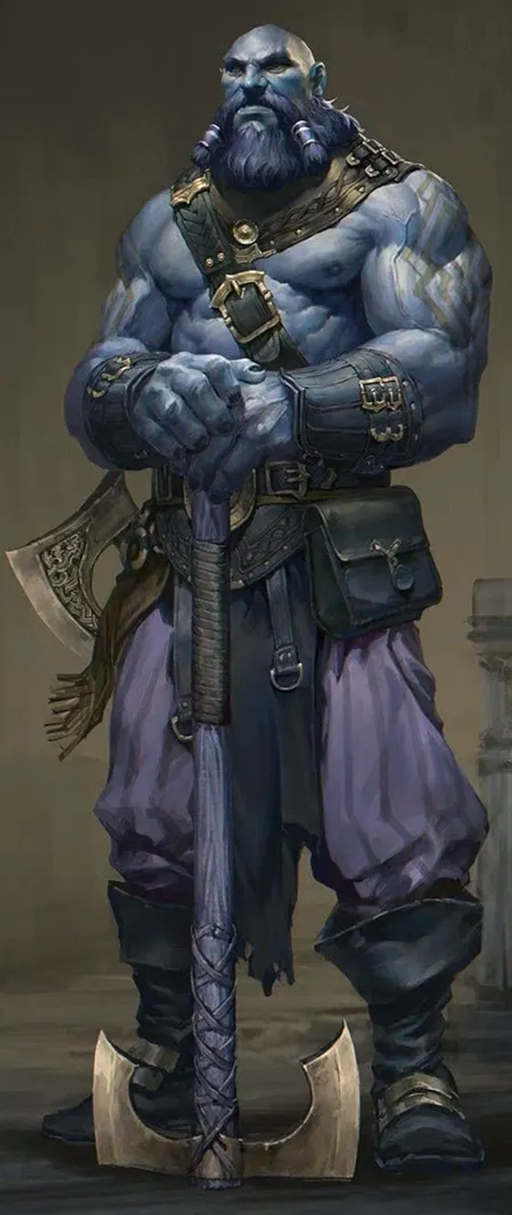
Goliath (s.)
The origins of Goliath are shrouded in myth, with some saying that their ancestors were born of Ice Giants.

Age. You are considered fully matured at twenty and live until about one-hundred. Goliath mothers always birth children in identical twins.
Size. Mechanically, your size is medium. You stand at about eight and a half feet tall. You weigh about 280 pounds.
Speed. Your speed is 30 feet per round.
Enduring Flesh. When you take damage, you can use your reaction to roll a d12. Add your Constitution modifier to the number rolled, and reduce the damage by that total. After you use this trait, you can’t use it again until you finish a short or long rest.
Powerful Form. You have proficiency in the Athletics skill. You count as one size larger when determining your carrying capacity and the weight you can push, drag, or lift.
Twin-things. If your twin is alive and you can see your twin, whenever you roll a 1 on an attack roll, ability check, or saving throw, you can reroll the die and must use the new roll. If your twin is dead, you can’t be frightened.

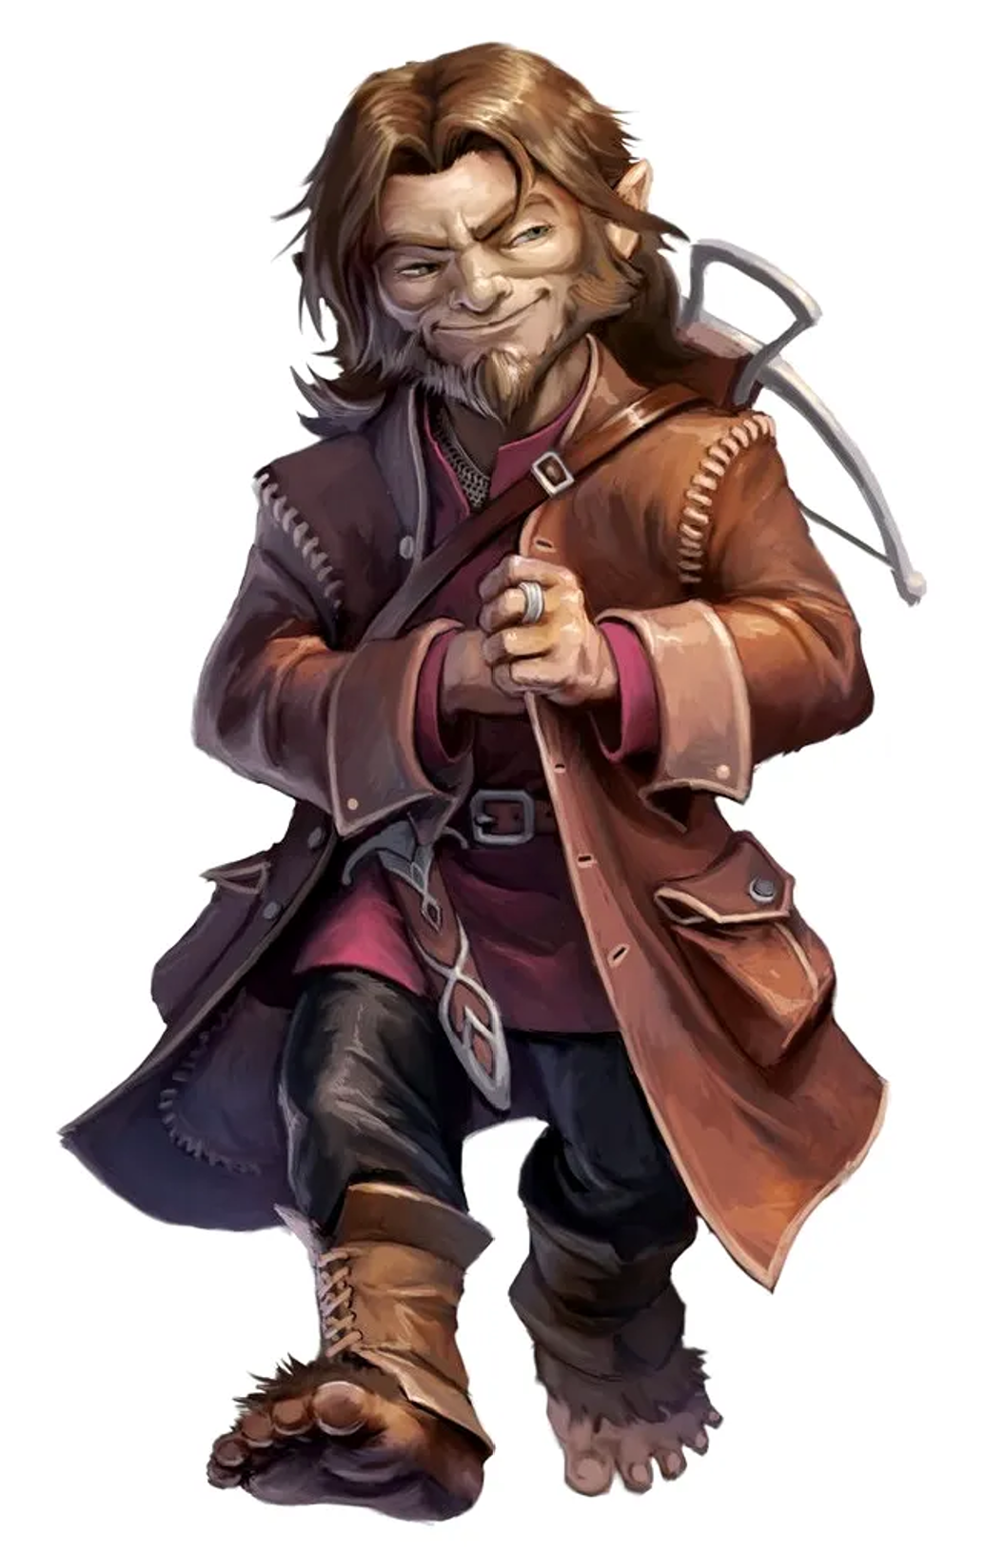
Halfling (a.)
Halfling are born of the Weave itself, the conscious form of a story of someone who did not exist. As this story is told, a halfling will be created based partially on the features and traits described in the tale they are born from. A halfling does not often meet their "storyteller", unless some sort of connection is woven into the tale.

Age. Halfling are considered fully mature at twenty five, and live until about one-hundred sixty. Halfling are born of story and creativity, they can become at any point in their life full of history and connection. Many halfling are cousin, sibling, parent, and child to many other halflings, as most of these halflings begin to tell stories of their family, they become too.
Size. Mechanically, your size is small. You stand at about three feet tall. You weigh about sixty pounds.
Speed. Your speed is 25 feet per round.
Plot-Armor. You have advantage on saving throws against being frightened. When you roll a 1 on an attack roll, ability check, or saving throw, you can reroll the die. You must use the new result, even if it is another 1.
Small Form. You can move through the space of any creature that is of a size larger than yours. You can attempt to hide even when you are only obscured by a creature that is at least one size larger than you.

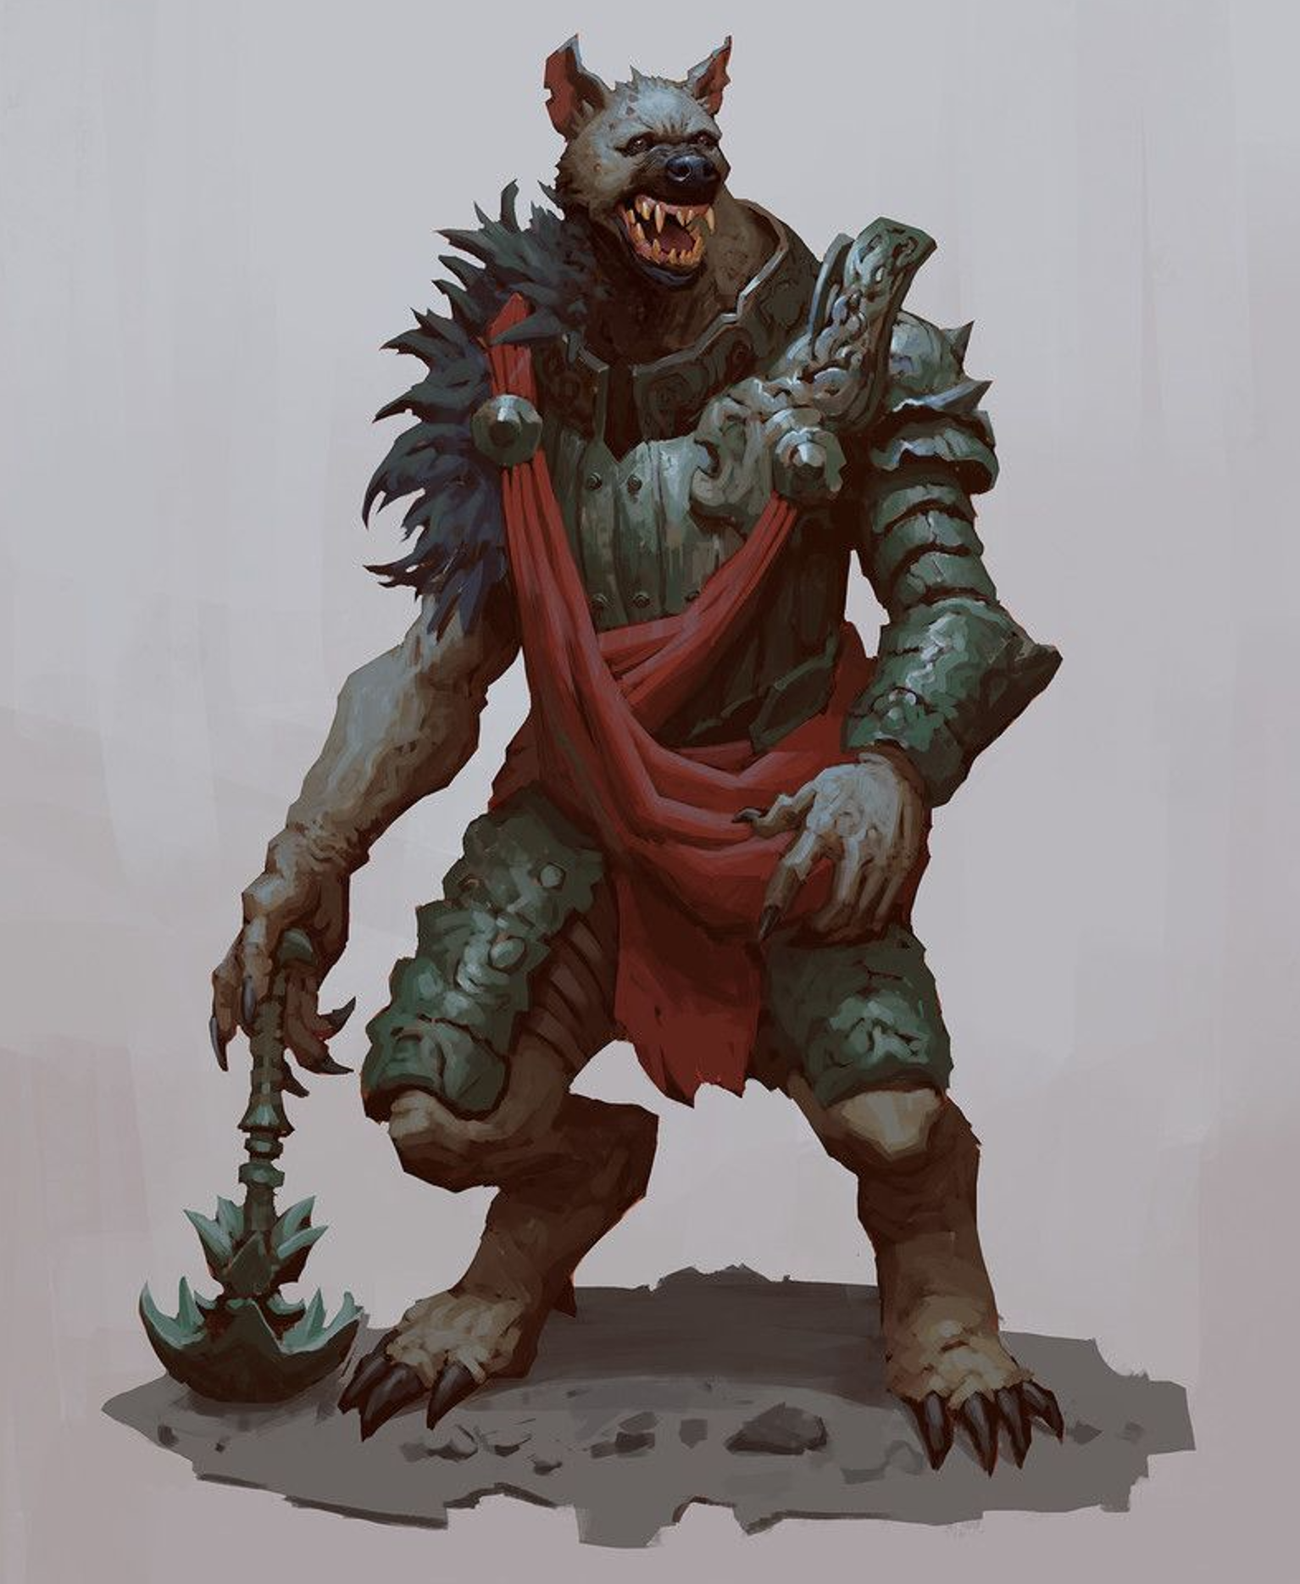
Gnoll (s.)
The origin tale of the Gnoll are known; they owe their existence to Orcus, the Demon Lord of the Undead, made to be his foot-soldiers against the humanoids of Alaturmen.

Age. You are considered fully matured at eight and live to about forty.
Size. Mechanically, your size is Medium. You stand at about six and a half feet tall. You weigh about 220 pounds.
Speed. Your speed is thirty-five feet per round.
Natural Maw. You are proficient with a Bite attack, which is a melee weapon attack that deals 1d6 piercing damage plus your Strength modifier. This Bite attack can replace any number of your weapon attacks when performing a Multiattack action or an Opportunity Attack reaction.
Demonic Ancestry. You are proficient in the Intimidation skill. When you reduce a creature to 0 hit points with a melee attack on your turn, you may use a bonus action to move up to half your speed and make up to one Bite attack.

Rare to Alaturmen
The following heritages are only rarely found on Alaturmen. I recommend selecting from this section only after you are comfortable in Alaturmen, or if you are willing to work with me and my concepts for what a character of the following heritages must be or know. My reasons for this generally stem from my concept of these being the most alien people you may play. An “average” commoner likely only knows stories about these heritages, if at all they know they exist.

Feywild

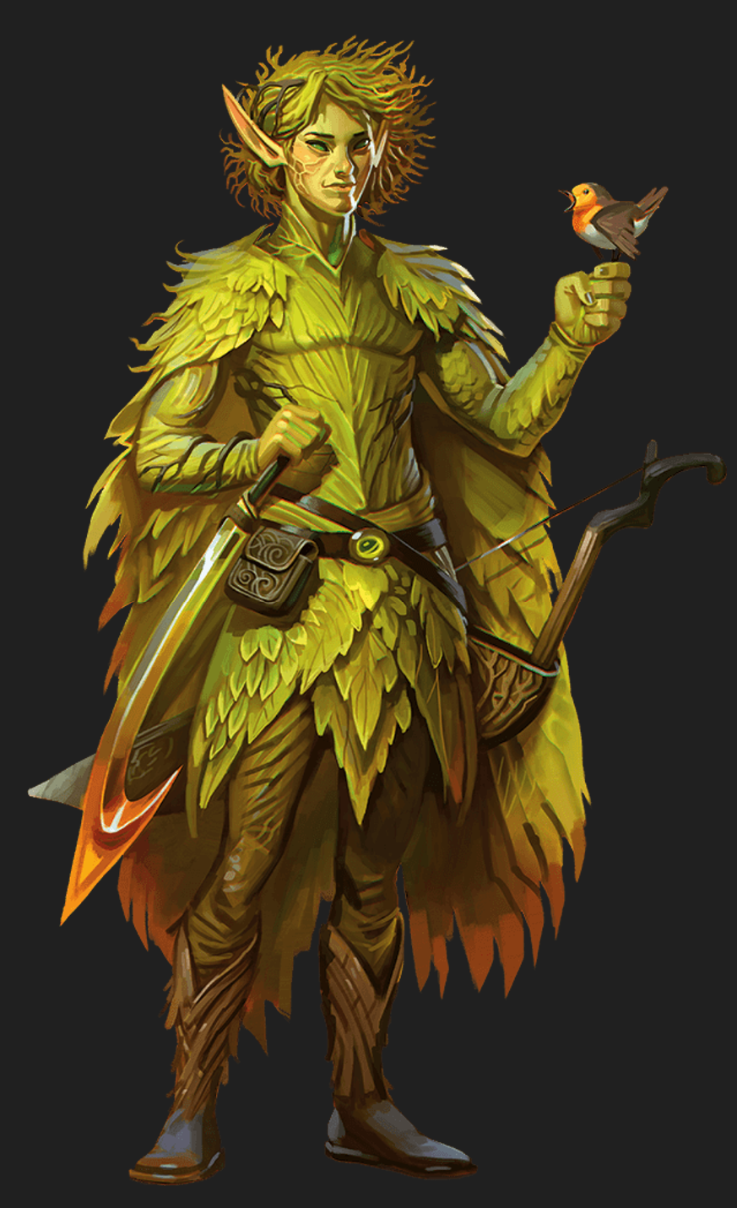
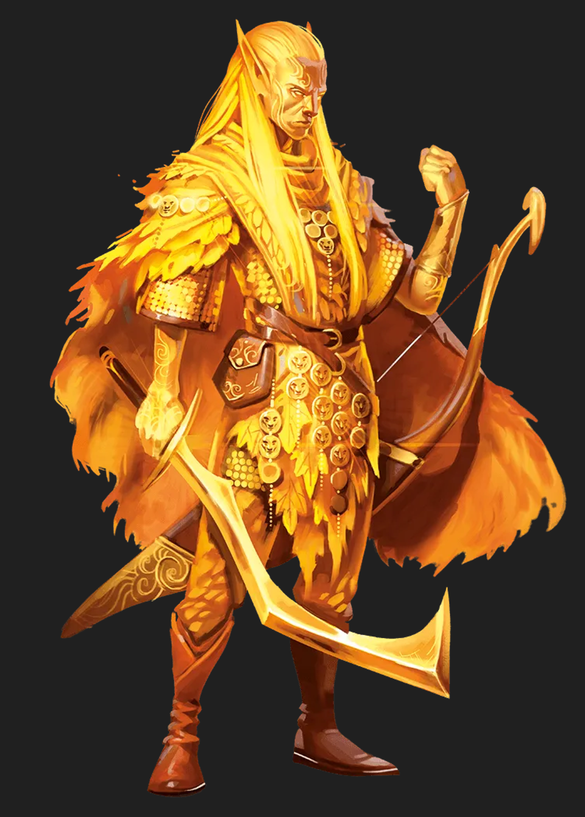
Eladrin (a.)
Eladrin are born of the Ceilie Courts, composing a large section of the courts' common fey.

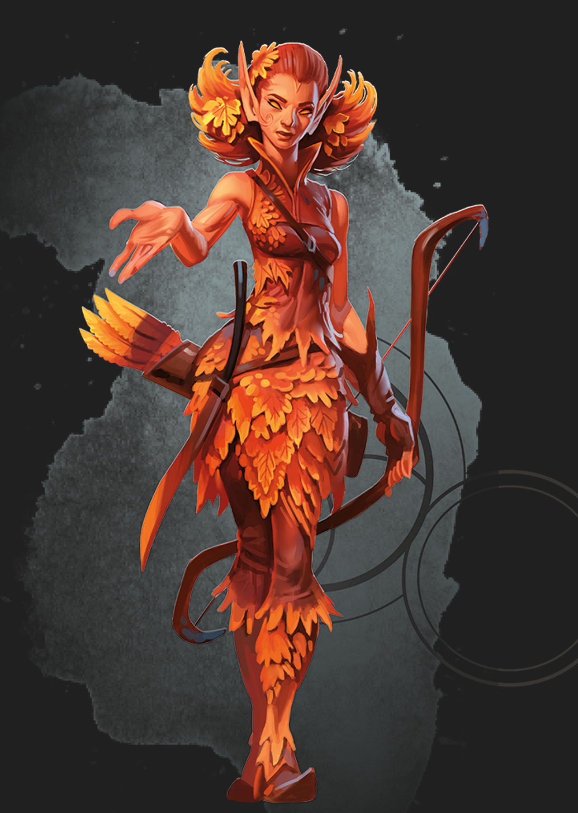
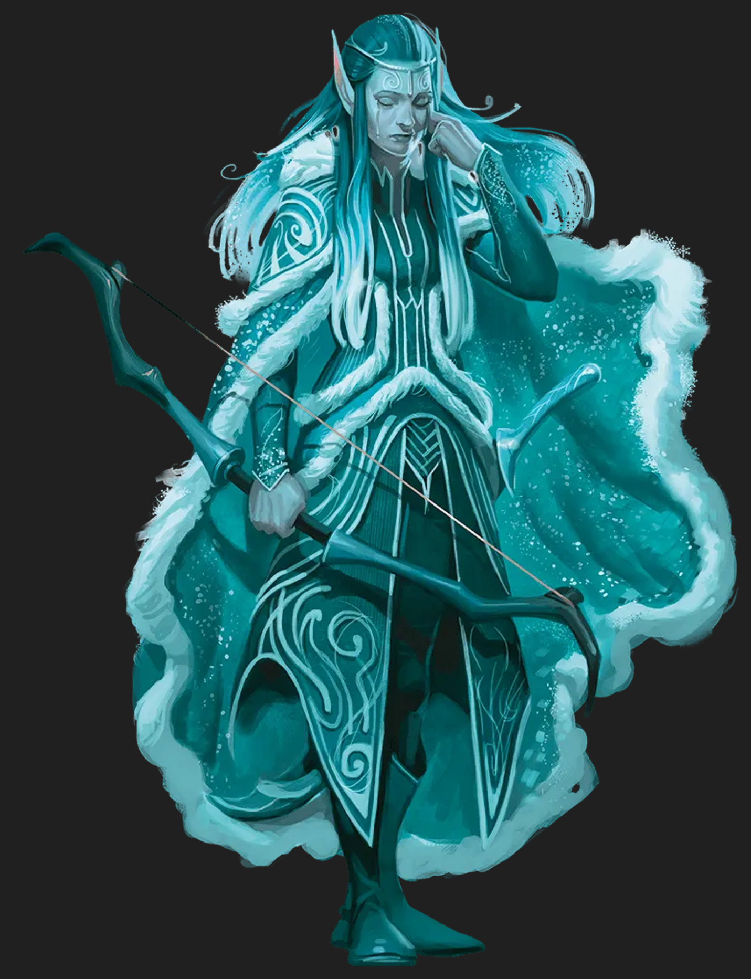
Age. Although you are considered fully mature at about twenty-five, the traditional eladrin perception of "adulthood" is based on worldly experience more than physicality. Additionally, one would change their name from that given at birth by their parents to that name they believe they have earned. As an eladrin reaches the end of their satisfied life, which generally happens sometime after three hundred years of life, they Walk beyond their home plane - whatever they may find. Eladrin parents must be integral in the full creation process of some artistic or creative work either directly before, during, or directly after the acts of conception.
Size. Mechanically, your size is Medium. You stand at about six feet tall. You weigh about one-hundred forty-five pounds.
Speed. Your speed is 30 feet per round.
Trance. You do not sleep. Instead you meditate deeply, remaining semi-conscious, for 4 hours a day. While meditating, you dream after a fashion; but such dreams are truly mental exercises you have developed and over time have become reflexive after your years of practice. After resting in this way, you gain the same benefit a human would from 8 hours of sleep.
Ceilie-Fey. You have advantage on saving throws against effects that charm and you cannot be made to sleep by magical means. Your creature type is fey, rather than humanoid. You also gain the following traits;
- Cantrip. You know one cantrip of your choice from the Wizard spell list. Intelligence is your spellcasting ability for it.
- Fey-Step. You may cast misty step as a bonus action. After using this feature, you cannot use it again until you complete a short or long rest.
- Trance Proficiencies. Whenever you finish a long rest using your Trance trait, you gain two proficiencies, each one with a weapon or a tool of your choice (selected from the “Equipment” chapter of the Player’s Handbook). You mystically acquire these proficiencies by drawing them from shared elven memory, and you retain them until you finish your next long rest.
Child of a Seasonal Monarch. You gain a trait corresponding to your seasonal ancestry;
- Spring. You know one cantrip of your choice from the Druid spell list. Wisdom is your spellcasting ability for it. When you use your Fey Step, you can touch one willing creature within 5 feet of you. That creature then teleports instead of you, appearing in an unoccupied space of your choice that you can see within 30 feet of you.
- Summer. You know one additional cantrip of your choice from the evocation school of the Wizard spell list. Intelligence is your spellcasting ability for it. Before or after you use your Fey Step, each creature of your choice within five feet of you takes fire damage equal to your proficiency bonus.
- Autumn. You know one cantrip of your choice from the Druid spell list. Wisdom is your spellcasting ability for it. Directly before or after you use your Fey Step, you gain resistance to all damage until the end of your next turn. During this time, your physical form is ghostly and ethereal.
- Winter. You have disadvantage on attack rolls and Wisdom (Spot) checks that rely on sight when you, the target of the attack, or whatever you are trying to perceive is in direct sunlight. You know one of the following cantrips of your choice: dancing lights, light, or sacred flame. Intelligence, Wisdom, or Charisma is your spellcasting ability for it. Directly before or after you use your Fey Step, each creature of your choice that you can see within 5 feet of you must succeed on a Wisdom saving throw or be frightened of you until the end of your next turn.

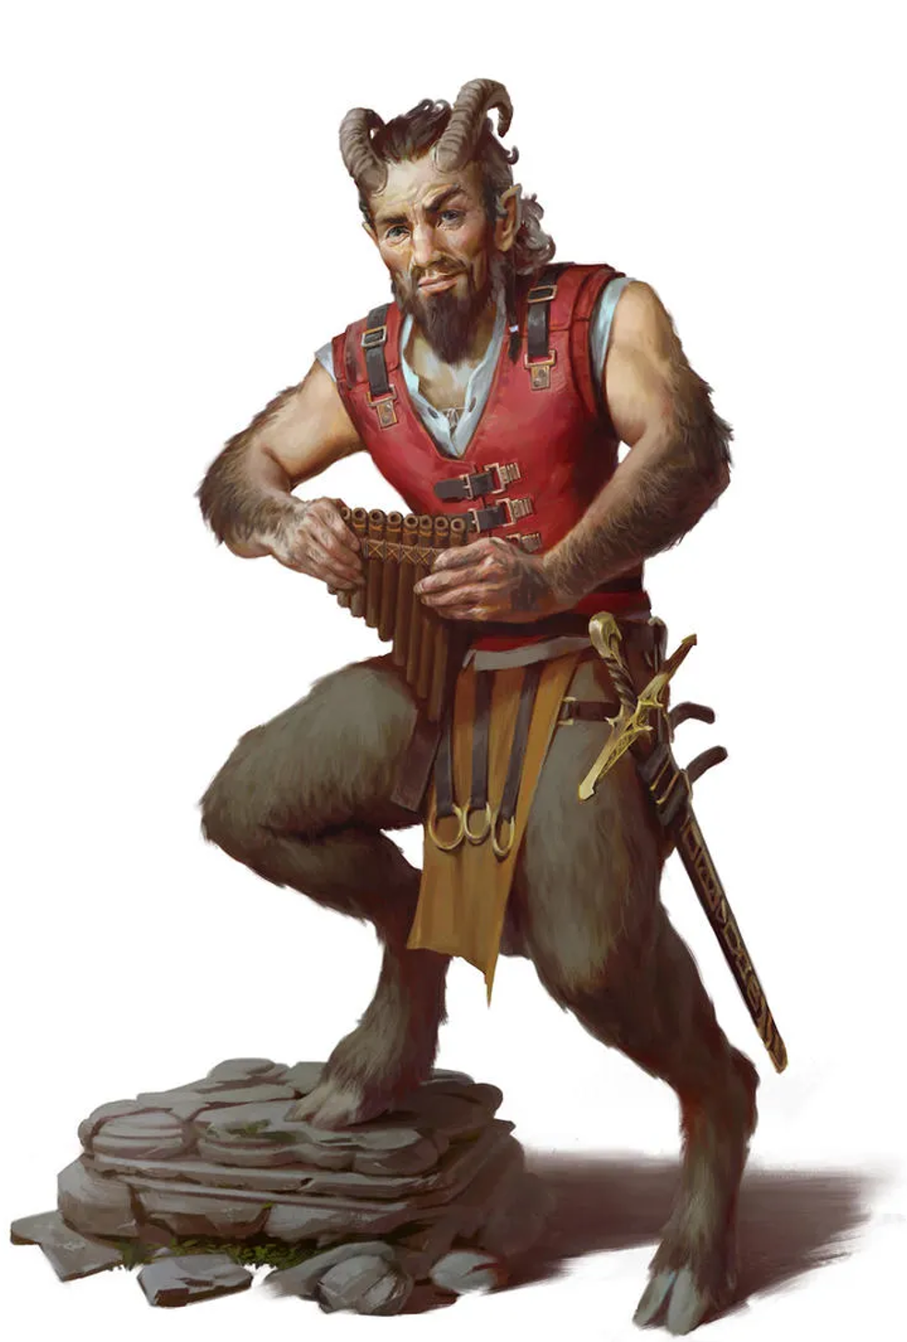
Satyr (a.)
Satyr are created by the Ceilie Courts, with the life directive of writing and telling the story of an event, person, or concept of their Court's choice.

Age. You are considered fully mature at twenty-five and live till about ninety. Satyr parent a single child at about seventy-five, whom they teach everything they know about their task.
Size. Mechanically, your size is Medium. You stand at about five feet tall.
Speed. Your speed is 30 feet per round. You have a climb speed of 5 feet per round; you are restricted by gravity as a humanoid.
Plot-Armor. You have advantage on saving throws against being frightened. When you roll a 1 on an attack roll, ability check, or saving throw, you can re-roll the die. You must use the new result, even if it is another 1.
Magical Reveler. You have advantage on saving throws against spells and other magical effects. You have proficiency in the Performance and Persuasion skills, and you have proficiency with one musical instrument of your choice.
Trance. You do not sleep. Instead you meditate deeply, remaining semi-conscious, for 4 hours a day. While meditating, you dream after a fashion; but such dreams are truly mental exercises you have developed and over time have become reflexive after your years of practice. After resting in this way, you gain the same benefit a human would from 8 hours of sleep.
Minor Ceilie-Fey. You have advantage on saving throws against effects that charm and you cannot be made to sleep by magical means. Your creature type is fey, rather than humanoid. You also gain the following traits;
- Cantrip. You know one cantrip of your choice from the Wizard spell list. Intelligence is your spellcasting ability for it.

Gnome (a.)
When a great work of invention is created in the multiverse, a Gnome becomes. Most find themselves born into the Astral Sea, adrift and surviving with nothing but their intellect to protect them.


Age. You are considered fully mature upon your becoming. You are a mortal, and while you would naturally die at about one-hundred twenty, many Gnomes extend their lifespans artificially; using magic or technology you could live to over five-hundred – or beyond, if you're willing to become something im-mortal.
Size. Mechanically, your size is Small. You stand at about two and a half feet tall. You weigh about forty pounds.
Speed. Your speed is 25 feet per round.
Magical Tinkerer. You have advantage on all Intelligence, Wisdom, and Charisma saves against magic. Whenever you make an Intelligence (History) check related to magical, alchemical, or technological items, you can add twice your proficiency bonus instead of any other proficiency bonus that may apply. Whenever you make an Intelligence (History) or an Ability Check involving artisans tools, you can roll a d4 and add the number rolled to the total ability check.
Minor Ceilie-Fey. You have advantage on saving throws against effects that charm and you cannot be made to sleep by magical means. Your creature type is fey, rather than humanoid. You also gain the following traits;
- Cantrip. You know one cantrip of your choice from the Wizard spell list. Intelligence is your spellcasting ability for it.

Underdark
These people come from a plane just below Alaturmen. The Underdark. The Deep Below. The Dug-too-Deep. Many names that inspire fear in those who truly understand what lurks beneath the surface of our world.

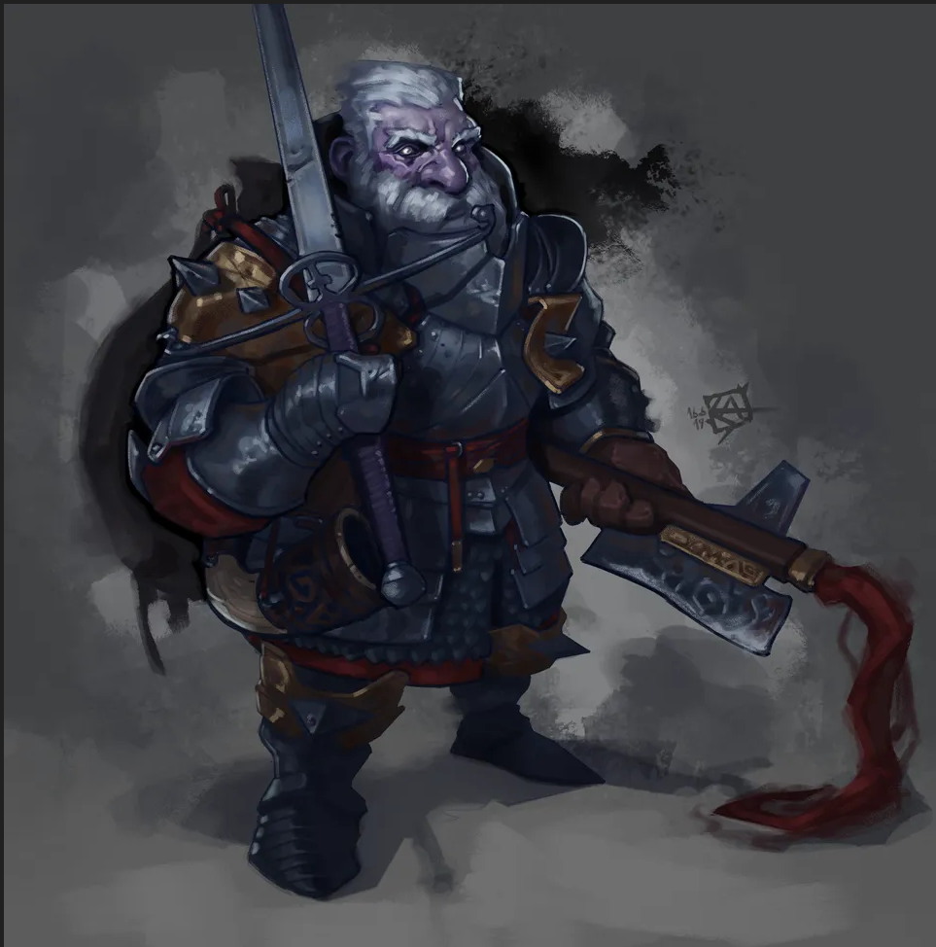
Duergar (a.)
A distant cousin of the Dwarves, the Duergar come from the Deep Below, a plane of caves, tunnels, horror, and riches. Duergar evolved for the deepest and darkest reaches of this place.

Age. You are considered fully mature at twenty-five, and live until about two-hundred twenty. Duergar reproduce ritually, in groups of two or more, and carve their children of stone, metal, and fine gem. Due to the process of carving a child, a parent will usually spend three months participating in this ritual, and will produce one child per participant. This gives duergar no reason to participate in gender, though they often have gender forced upon them in alien cultures.
Size. Mechanically, your size is Medium. You stand at four and a half feet tall. You weigh about 230 pounds.
Speed. Your speed is twenty-five feet per round.
Superior Darkvision. You can see in dim light within 120 feet of you as if it were bright light, and in darkness as if it were dim light. You can't discern color in darkness, only shades of gray. You have disadvantage on attack rolls and on Wisdom (Spot) checks that rely on sight when you, the target of your attack, or whatever you are trying to perceive is in direct sunlight.
Elemental Ancestry (Earth). You have advantage on saving throws against poison, and you have resistance against poison damage. Whenever you make an Intelligence (History) check related to the origin of stonework, you are considered proficient in the History skill and add double your proficiency bonus to the check, instead of your normal proficiency bonus. Your hit point maximum increases by 1, and it increases by 1 every time you gain a level.

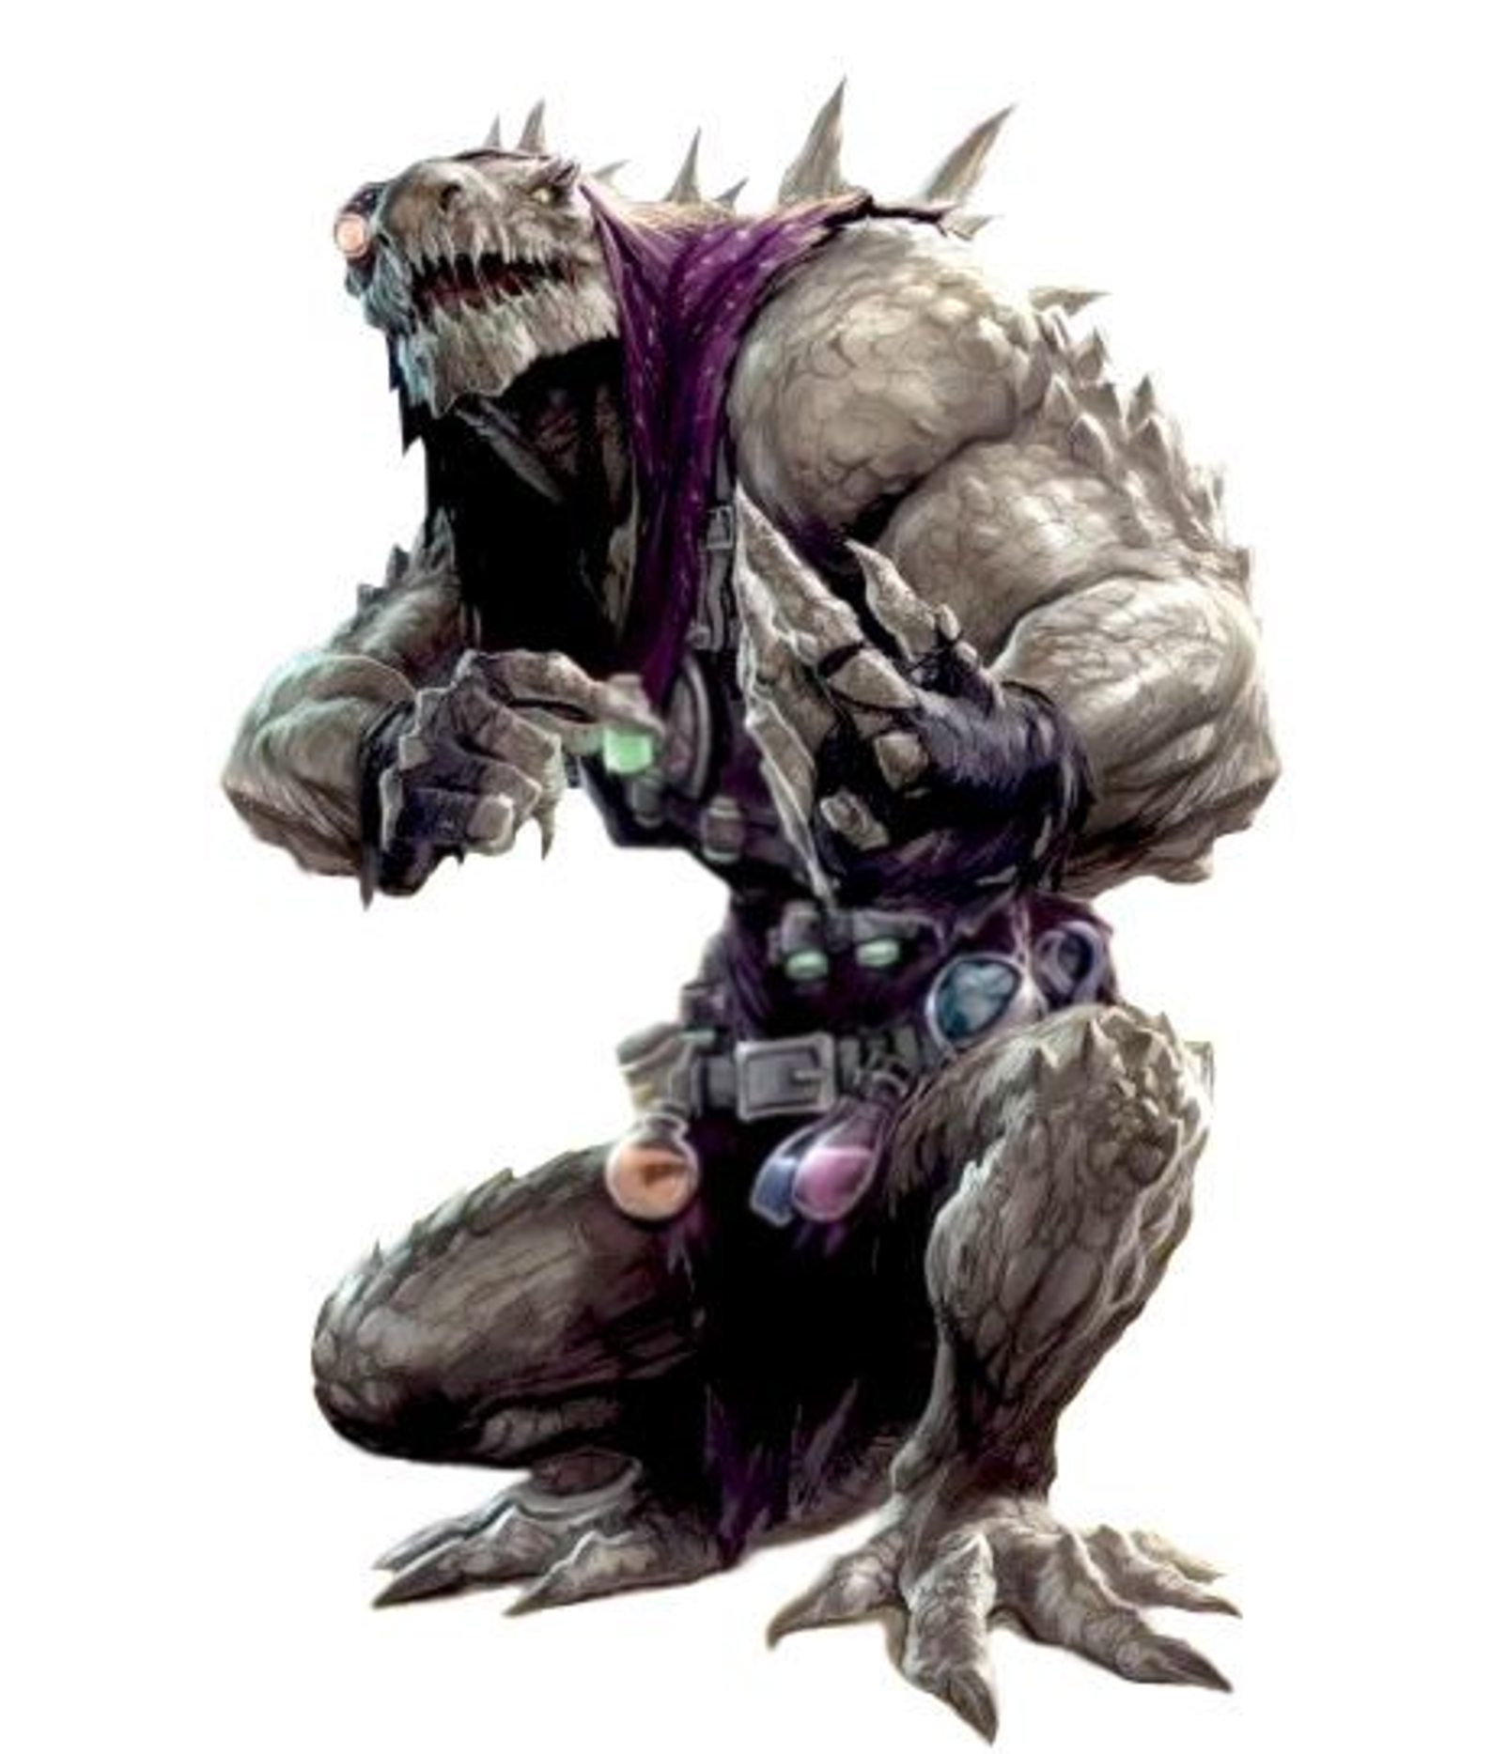
Kalix (s.)
The Kalix evolved in the Deep Below, a plane of caves, tunnels, horror, and riches. They are evolved for the damp lush areas of this place.

Age. You are considered fully matured at eight and live to about forty.
Size. Mechanically, your size is Medium. You stand at about six and a half feet tall. You weigh about 220 pounds.
Speed. Your speed is 35 feet per round. You gain a swimming speed of 30.
Darkvision. You can see in dim light within 60 feet of you as if it were bright light, and in darkness as if it were dim light. You can't discern color in darkness, only shades of gray.
Amphibious. You can breathe air and water.
Enduring Flesh. When you take damage, you can use your reaction to roll a d12. Add your Constitution modifier to the number rolled, and reduce the damage by that total. After you use this trait, you can’t use it again until you finish a short or long rest.
Natural Claws & Maw. You are proficient with a Claw or Bite attack, which is a melee weapon attack that deals 1d4 or 1d6, respectively, piercing damage plus your Dexterity or Strength modifier, for a Claw attack or Bite attack respectively. This Claw or Bite attack can replace any number of your weapon attacks when performing a Multiattack action or an Opportunity Attack reaction.

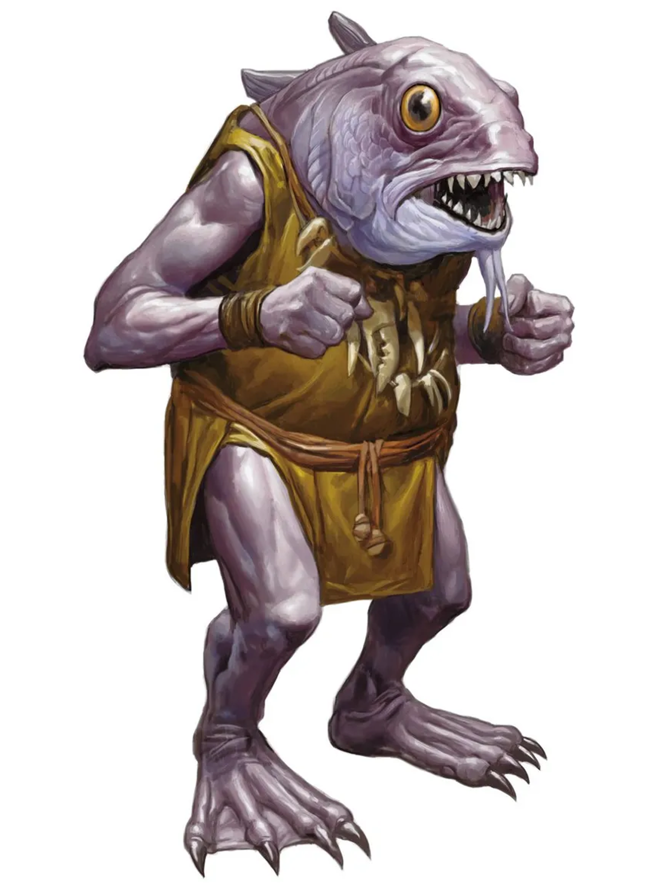
Kuo-Toa (s.)
The Kuo-Toa evolved in the Deep Below, a plane of caves, tunnels, horror, and riches. They evolved for life in the wettest places here.

Age. You are considered fully mature at fourteen and live to be about seventy. Kuo-Toa reproduce like traditional fish, fathers inseminate hundreds of a mother's eggs.
Size. Mechanically, your size is small. You stand at about two and a half feet tall. You weigh about sixty pounds.
Speed. Your speed is 25 feet per round. You gain a swimming speed of 30 feet per round.
Darkvision. You can see in dim light within 60 feet of you as if it were bright light, and in darkness as if it were dim light. You can't discern color in darkness, only shades of gray.
Amphibious. You can breathe air and water.
Small Form. You can move through the space of any creature that is of a size larger than yours. You can attempt to hide even when you are only obscured by a creature that is at least one size larger than you.

Elementals
These people all share heritage in the Elemental Planes, just a close jog through the Astral Sea away from Alaturmen.

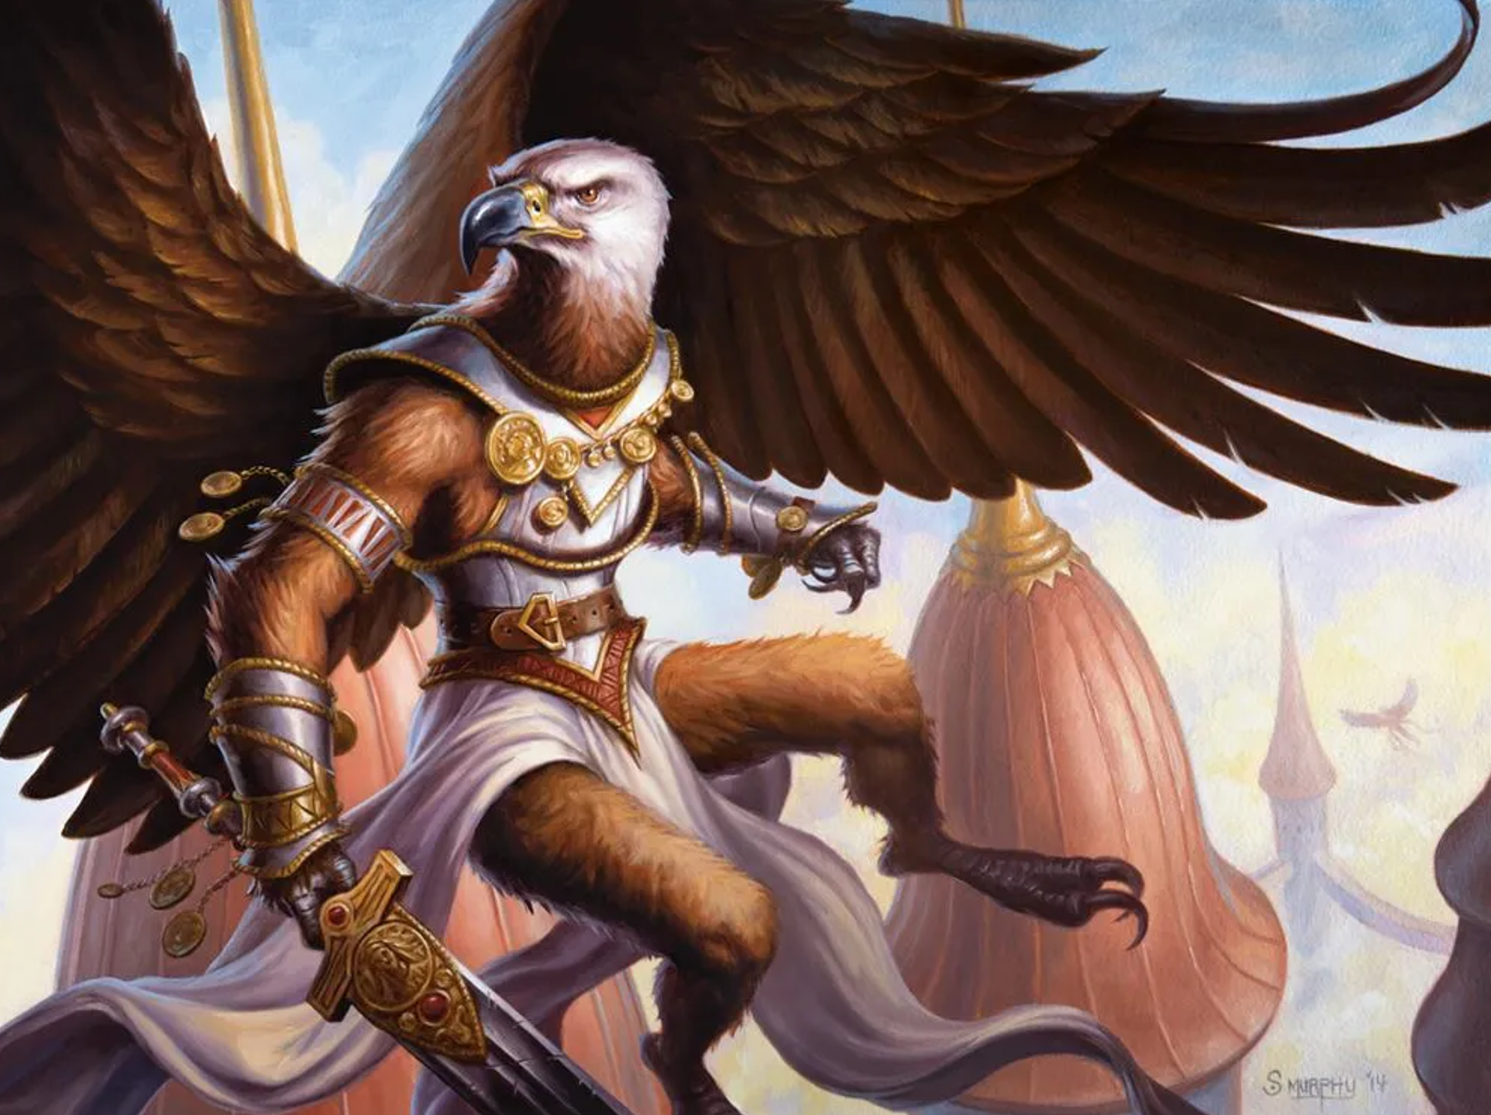
Aaracokra (s.)
Hollow boned humanoid-birdfolk native to the Elemental Plane of Air.

Age. You are considered fully mature at six and live to be about sixty.
Size. Mechanically, your size is medium. You stand at about five and a half feet tall. You weigh about one-hundred thirty pounds.
Speed. Your speed is 30 feet per round.
Natural Talons. You are proficient with a Claw attack, which is a melee weapon attack that deals 1d4 piercing damage plus your Dexterity modifier. This Claw attack can replace any number of your weapon attacks when performing a Multiattack action or an Opportunity Attack reaction.
Elemental Ancestry (Air). You gain a flying speed of 50 feet per round, though you cannot use this speed when you are wearing medium or heavy armor. You can hold your breath indefinitely while you’re not incapacitated.


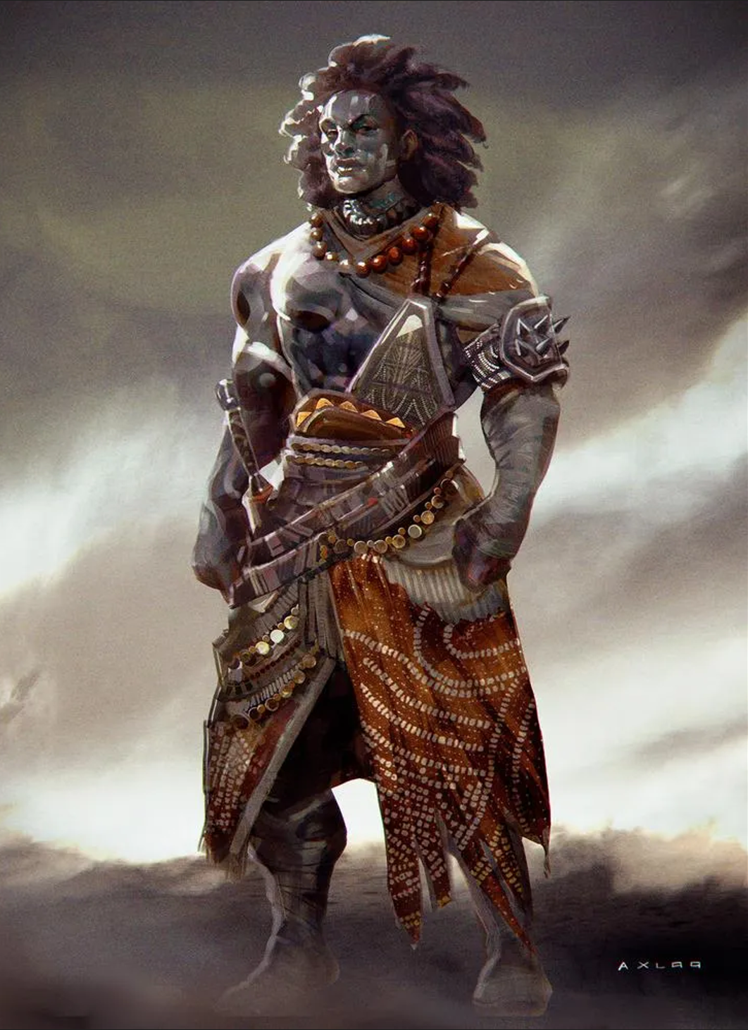
Genasi (a.)
Genasi are humanoid elementals native to the Elemental Planes. Those Genasi who find themselves on Alaturmen typically came of their own volition.

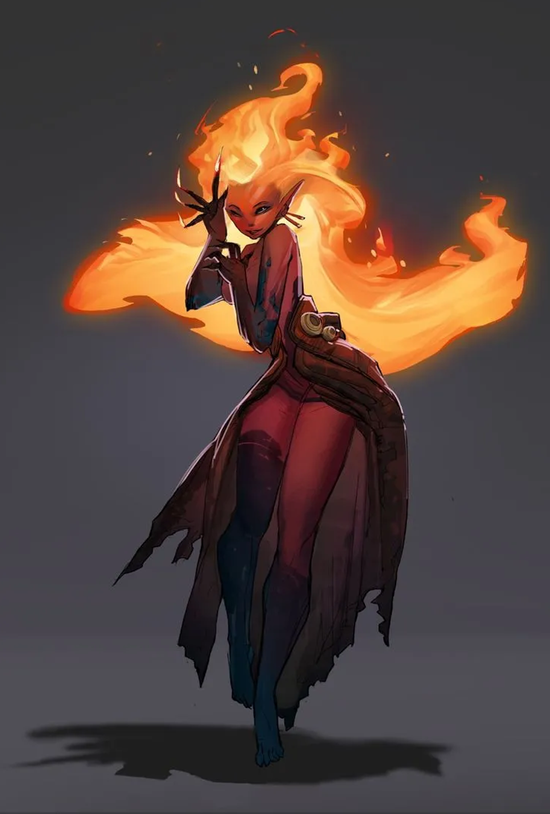
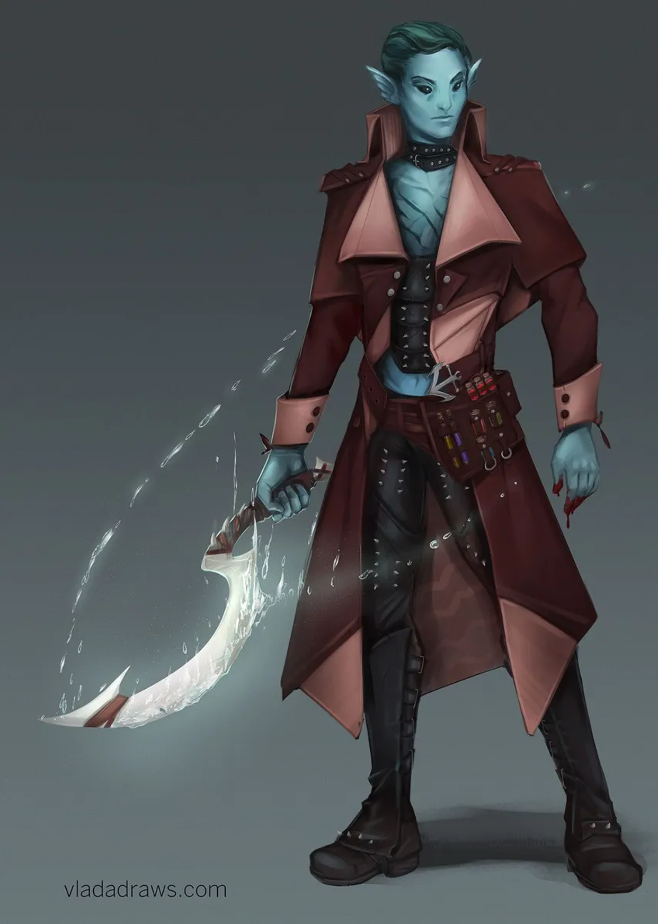
Age. You are considered fully mature at about forty and live to about four-hundred years.
Size. Mechanically, your size is Medium. You stand at about six feet tall. You weigh about one-hundred forty-five pounds.
Speed. Your speed is 30 feet per round.
Elemental Ancestry. You gain your choice of one of the following traits;
- (Air). You gain a flying speed of 50 feet per round, though you cannot use this speed when you are wearing medium or heavy armor. You can hold your breath indefinitely while you’re not incapacitated.
- (Earth). You have immunity against poison damage and the poisoned condition. Whenever you make an Intelligence (History) check related to the origin of stonework, you are considered proficient in the History skill and add double your proficiency bonus to the check, instead of your normal proficiency bonus. Your hit point maximum increases by 1, and it increases by 1 every time you gain a level.
- (Water). Adapted to even the most extreme ocean depths, you have resistance to cold damage. Aquatic beasts have an extraordinary affinity with your people. You can communicate simple ideas with beasts that can breathe water. They can understand the meaning of your words, though you have no special ability to understand them in return. You know the cantrip shape water. Constitution is your spellcasting ability for this spell.
- (Fire). You have resistance to fire damage. You can see in dim light within 60 feet of you as if it were bright light, and in darkness as if it were dim light. Your ties to the Elemental Plane of Fire make your darkvision unusual: everything you see in darkness is in a shade of red. You may cast hellish rebuke as a reaction. Constitution is your spellcasting ability for this spell. After using this feature, you cannot use it again until you complete a short or long rest.
Outer-Planer
These people are born or formed with ideology pumping through their veins. The Outer Planes are home to Demons, Devils, Angels, and Licitus – bastions of extremism. The spirits of mortals move here too, after they become un-teathered from the Material Plane.

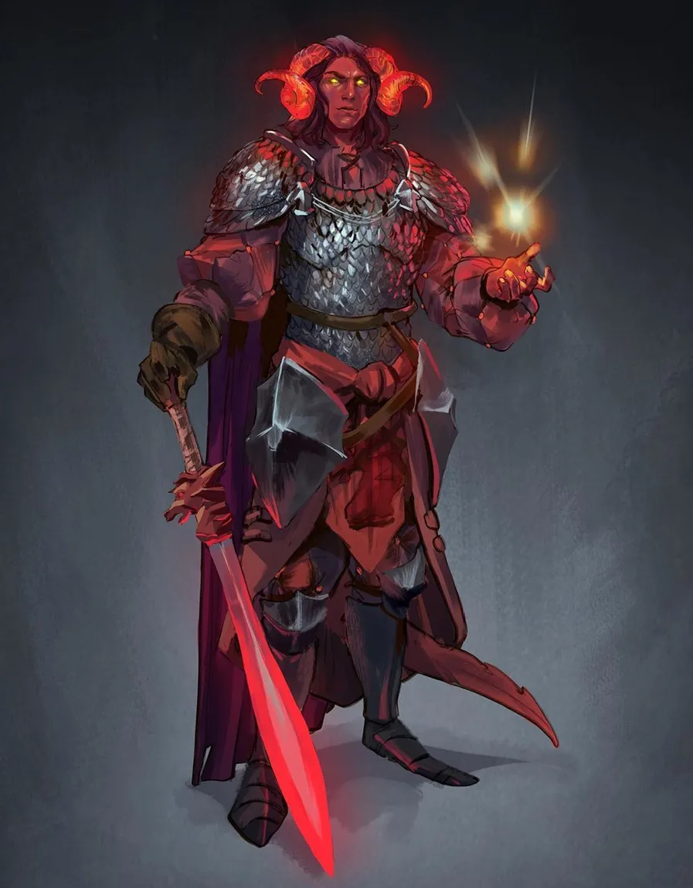
Tiefling (s.)
Tiefling are the children of Devils and humanoids. Often, they are born of contract ("I give you my first born child, and in exchange..."), but other times, a human and a devil truly fall into what they consider love and bear a tiefling together.

Age. You are considered fully mature at twenty-five, and live until about one-hundred eighty. A tiefling is born in the union of a devil and a humanoid, and tieflings cannot themselves bear children. The humanoid parent always bears the teifling child to term, and to do so is very often fatal.
Size. Mechanically, your size is Medium. You stand at about five feet tall. You wiegh about one-hundred sixty pounds.
Speed. Your speed is thirty feet per round.
Devilish Ancestry. Choose 1d4 + 1 of the following features: small horns; fangs or sharp teeth; a forked tongue; catlike eyes; six fingers on each hand; goat-like legs; cloven hoofs; a forked tail; leathery or scaly skin; dark or vibrant colored skin; cast no shadow or reflection; exude a smell of brimstone. You gain these features as aspects of your appearance and a manifestation of your Devilish Ancestry. In addition, you gain your choice of one of the following traits;
- Avernus Child. You know the Thaumaturgy cantrip. When you reach 3rd level, you can cast the Searing Smite spell as a 2nd-level spell once with this trait and regain the ability to do so when you finish a long rest. When you reach 5th level, you can cast the Branding Smite spell once with this trait and regain the ability to do so when you finish a long rest. Charisma is your spellcasting ability for these spells.
- Dis Child. You know the Thaumaturgy cantrip. Once you reach 3rd level, you can cast the Disguise Self spell once with this trait and regain the ability to do so when you finish a long rest. When you reach 5th level, you can cast the Detect Thoughts spell once with this trait and regain the ability to do so when you finish a long rest. Charisma is your spellcasting ability for these spells.
- Minaurus Child. You know the Mage Hand cantrip. When you reach 3rd level, you can cast the Tenser's Floating Disk spell once with this trait and regain the ability to do so when you finish a short or long rest. When you reach 5th level, you can cast the Arcane Lock spell once with this trait, requiring no material component, and regain the ability to do so when you finish a long rest. Charisma is your spellcasting ability for these spells.
- Phelgetos Child. You know the Friends cantrip. When you reach 3rd level, you can cast the Charm Person spell as a 2nd-level spell once with this trait and regain the ability to do so when you finish a long rest. When you reach 5th level, you can cast the Suggestion spell once with this trait and regain the ability to do so when you finish a long rest. Charisma is your spellcasting ability for these spells.
- Stygia Child. You know the Ray of Frost cantrip. When you reach 3rd level, you can cast the Armor of Agathys spell as a 2nd-level spell once with this trait and regain the ability to do so when you finish a long rest. When you reach 5th level, you can cast the Darkness spell once with this trait and regain the ability to do so when you finish a long rest. Charisma is your spellcasting ability for these spells.
- Malbolge Child. You know the Minor Illusion cantrip. When you reach 3rd level, you can cast the Disguise Self spell once with this trait and regain the ability to do so when you finish a long rest. When you reach 5th level, you can cast the Invisibility spell once with this trait and regain the ability to do so when you finish a long rest. Charisma is your spellcasting ability for these spells.
- Maladomini Child. You know the Vicious Mockery cantrip. Once you reach 3rd level, you can cast the Charm Person spell once as a 2nd-level spell. Once you reach 5th level, you can also cast the Enthrall spell once. You must finish a long rest to cast these spells again with this trait. Charisma is your spellcasting ability for these spells.
- Cania Child. You know the Mage Hand cantrip. When you reach 3rd level, you can cast the Burning Hands spell as a 2nd-level spell once with this trait and regain the ability to do so when you finish a long rest. When you reach 5th level, you can cast the Flame Blade spell once with this trait and regain the ability to do so when you finish a long rest. Charisma is your spellcasting ability for these spells.
- Nesus Child. You know the Thaumaturgy cantrip. Once you reach 3rd level, you can cast the Hellish Rebuke spell once as a 2nd-level spell. Once you reach 5th level, you can also cast the Darkness spell once. You must finish a long rest to cast these spells again with this trait. Charisma is your spellcasting ability for these spells.

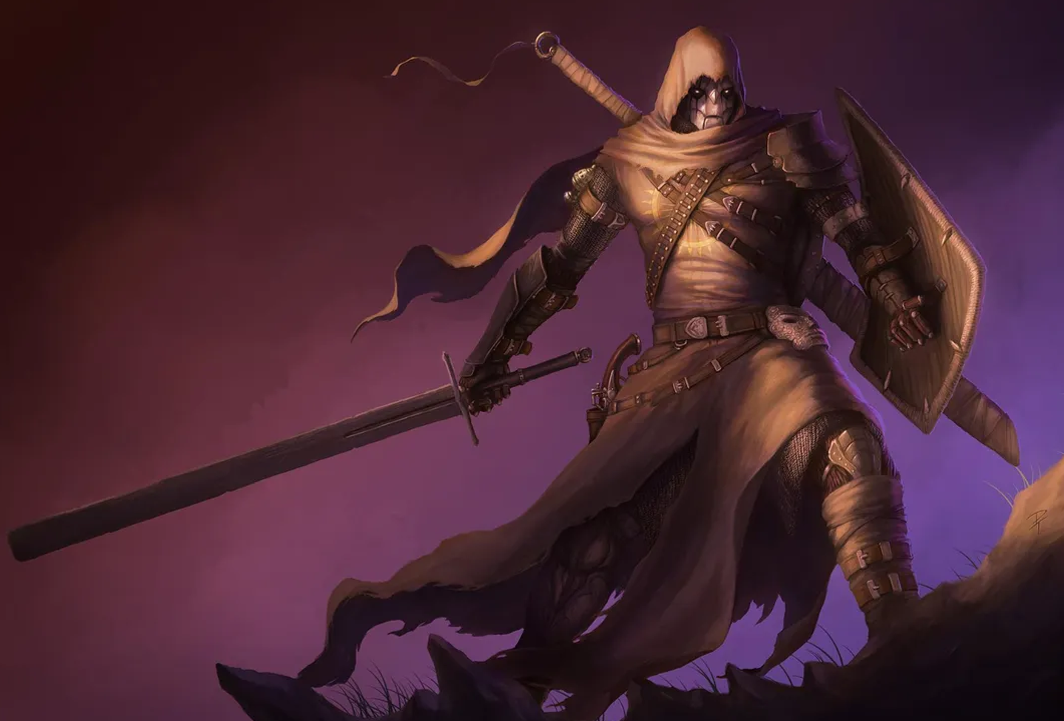
Mecha (a.)
Mecha are the lawful reformation of a Faith-full Soul. A soul that passes into Mechanis becomes a Mecha here, though they are stripped of any previous sense of self, they are allowed the memories of their soul's owner.

Age. You are considered fully mature, and you do not age.
Size. Mechanically, your size is Medium. You stand at five feet tall. You weigh four-hundred thirty five pounds, seven ounces precisely.
Speed. Your speed is 30 feet per round.
Constructed Form. Your creature type is construct. You cannot perform acts that the fates would consider chaotic ("we care not the petty laws of man, but the laws of nature, of power"). You gain the following benefits;
- You have immunity against being poisoned and to poison damage.
- You are immune to disease.
- You don't need to sleep, and magic cannot put you to sleep. When you take a long rest, you must spend at least six hours in an inactive, motionless state, rather than sleeping. In this state, you appear inert, but it doesn’t render you unconscious, and you can see and hear as normal.
- You don’t need to eat, drink, or breathe.
- You can don only armor with which you have proficiency.
- To don armor, you must incorporate it into your body over the course of 1 hour, during which you must remain in contact with the armor. To doff armor, you must spend 1 hour removing it. You can rest while donning or doffing armor in this way.
- While you live, your armor can't be removed from your body against your will.
Versatile Form. You gain proficiency in a skill of your choice. You gain one feat of your choice. You may increase one ability score of your choice by one.

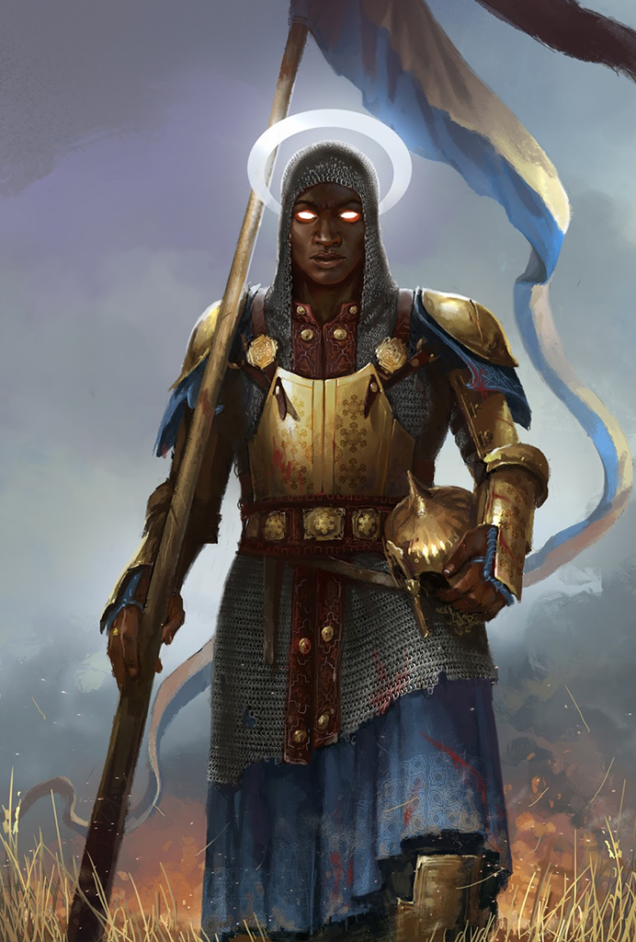
Aasimar (a.)
Aasimar are the good reformation of a Faith-full Soul. A soul that passes into Elysium becomes a Aasimar here, though they are stripped of any previous sense of self, they are allowed the memories of their soul's owner.

Age. You are considered fully mature, and you do not age.
Size. Mechanically, your size is Medium. You stand at about seven feet tall. You weigh about four-hundred pounds.
Speed. Your speed is 30 feet per round. You gain a hover speed of 5 feet per round.
Celestial Ancestry. Your creature type is celestial. You cannot perform acts that the fates would consider evil. You gain the following benefits;
- You have resistance to necrotic damage and radiant damage.
- You know the Light cantrip. Once you reach 3rd level, you can cast the Lesser Restoration spell once using this trait, and you regain the ability to do so when you finish a long rest. Once you reach 5th level, you can cast the Daylight spell once with this trait as a 3rd level spell, and you regain the ability to do so when you finish a long rest. Charisma is your spellcasting ability for these spells.
- As a reaction, you may cast protection from evil and good on yourself or one creature within five feet of you. You cannot use this feature until you complete a long rest.
Powerful Form. You have proficiency in the Athletics skill. You count as one size larger when determining your carrying capacity and the weight you can push, drag, or lift.

Wha! Wha! I wanna be an asshole at the table!
You may have noticed that there is no Chaotic or Evil counterparts to the Mecha or the Aasimar. This was a purposeful design choice; you do not get to play Demons or Devils at my table. Full stop, no exceptions.

There are plenty enough ways to perform evil or induce chaos without having the inability to perform acts of good or lawfulness.

Try a human.

Culture
Your culture bestows in you some traits and ideals that can be mechanically represented by Ability Score Increases, Skills, and Languages, and/or some other culturally endowed traits. I mention your culture's Alignment at the end of it's description, though I never use the word, and to be clear; This is not your assigned Alignment. You may take it if you so choose but your character's alignment need not reflect their culture's, but it should reflect their actions.

If you decide that your character's alignment needs to shift to more accurately represent their actions, please do so, but if this is more like a character arc thing you should come talk to me.

Nation-States of Coalition
Banded by treaty and bond, these four nations, and their daughter capital-city-state, are together known as Coalition.

Kingdom of Prosper
After the Fall of Tetrimoc, and the entrance of sentient life unto Alaturmen, a group of so-called "Bandit Lords" ruled the Great Northern Forests. Only six years later, they fall in the West, but here in the East, they ruled for another forty years.

They fell to the Adventurer King Arthur Simonson, who now rules the Kingdom of Prosper. Since his reign, places such as Gambleum, Janesland, and Yerba have, as promised, Prospered, as well have the smaller settlements under his influence. He extends his reach far into the northwest, reaching into what's left of the Great Northern Forests at risk of angering the Blood Clans at these borders.

The state-mandated-education in Prosper teaches children to read and write, as well as promoting personal hardiness and community focus; It is an honor to know your neighbor, and it is a pleasure to host them in your home. The people of Prosper have a history of near-virtuous violence, and they raise their children to defend themselves. The culture of Prosper is one of Lawful Goodness; their system of government is good and kind, and they are bound to their fellows through the experience of life.

Ability Score Increase. Your Strength score increases by 1, and your Intelligence score increases by 1.
Languages. You know at least these two languages; King's Common (language) and Goblin (language).
Skills. You are proficient in Intelligence (Nature), Wisdom (Survival), and one set of tools of your choice.
Martial Discipline. You are proficient with light and medium armors, as well as all basic and martial weapons. You have advantage on saving throws against being frightened.

Church of the White Flame
The Church of the White Flame rose from the ashes of the North-West – after the Great Fires immolated this place people flocked to their new deity. Quickly, a caste-theocracy formed around The Holy Flame and It's wishes.

The few who claim to have Spoken with Its Greatness claim the top of this system, and those who are fiercely loyal (and properly propagandized) become Firstchurch or Tendered. The common folk are given the name Patrons, and those below them – the slaves or those otherwise untouched by the White Flame – are called Unseen or, in the case of an enemy, Undesirable.

The culture of the Church is one of Lawful Evil; violence is necessary to do what It wills, and thus is virtuous, and people of this church are comfortable with the understanding that some people simply are not worth as much as others.

Ability Score Increase. Your Dexterity score increases by 1, and your Wisdom increases by 1.
Languages. You know at least two languages; High Common (language) and Modern Elven (language).
Skills. You are proficient in Intelligence (Religion), Wisdom (Survival), and one set of tools of your choice.
Mental Discipline. You have resistance to psychic damage. You have advantage on all Wisdom saving throws.

Golden City
When Tetrimoc fell to the world, and sentience was born unto Alaturmen, he made his lair in The Deserts of Tetrimoc, boring deep into the desert. The people of these Deserts came to him here and built him, and themselves, a beautiful city of gold and sand. Those who live in the Golden City are of two kinds; with power and without. These two groups fight to take what the other has every day in this place, through law and chaos. Many who live here revere Tetrimoc, and those who don't at least respect him – the city is made of his home after all.

For as long as people have been here, they have been protected by Tetrimoc, and though the Golden Light, Planeblood, Tetrimoc the Progenitor himself has not been seen for about a dozen years, the people of the Golden city take comfort in High Ambassador Venclaw's claims that he is in constant communication with the Dragon of the Golden City.

The culture of the Golden City is one of True Neutrality; while there are laws here, they benefit those in power much more than those out of power, and they are enforced much more than they are respected. Crime is a necessary component of the City's economy, and day-to-day survival for many.

Ability Score Increase. Your Charisma score increases by 1, and your Intelligence score increases by 1.
Languages. You know at least these two languages; Desertspeech (language) and Draconic (language).
Skills. You are proficient in Intelligence (History), Charisma (Persuasion), and one set of tools of your choice.
Desert Proficiency. You gain advantage on Dexterity (Initiative) and Dexterity (Stealth) checks while you are in a desert.

Democratic Combine of Peoples
When Tetrimoc fell, and sentient life became on Alaturmen, the People of the South-East found themselves in a bountiful wet land. People formed tribes, clans, monarchies, made war and trade, and as the Coalition was formed, the rules of combat between these Peoples was formalized in Coalition's Founding Document, and The Democratic Combine of Peoples was formed.

The peoples of the DCP are ruled by their Barons, nearly all of whom fight among themselves while the Combine as a whole is not under threat. These barons find use for all who live within their domain, leading to an eclectic gathering of people in a Baron's Court.

The culture of the DCP is one of Neutral Good; the commoners are happy for the laws of the Coalition and the protection of their Baron. Chaos is rampant here – crime and war are the status-quo, and everyone has an angle. The seat of Baron is open – if you can take it.

My Baron Can Beat Up Your Baron. You gain either one feat of your choice or an Ability score of your choice increases by 2.
Languages. You know at least these two languages; Swampish (language) and Aquarian (language).
Skills. You are proficient in Wisdom (Survival), Wisdom (Insight), and one set of tools of your choice.
War-born. When you score a critical hit with a weapon attack, you can roll one of the weapon’s damage dice one additional time and add it to the extra damage of the critical hit.

Coalition City
Expose
government/dominant culture-ism
alignment/disposition

Non-Coalition Entities

Dwarven Kingdom Suremantle
The Dwarven Kingdom of Suremantle is a monarchy supported by family clans of miner and farmers. These clans are as ancient as Alaturmen, and claim that their ancestors were carved from the stone here, a hundred or more years ago.

The Kingdom Suremantle claims all the reaches of Mountain Hall; a massive sub-surface structure that spans much of the Deakred Range. The culture of this place promotes pseudo-isolationism; interacting with people from other cultures is only acceptable under the circumstances of trade.

The culture of Suremantle is one of Neutral Evil. The people here are ignorant and arrogant of other cultures, and they promote a family-before-self-before-other culture.

Ability Score Increase. Your Strength score increases by 1, and your Constitution score increases by 1.
Languages. You know at least these two languages; Dwarven (language) and Desertspeech (language).
Skills. You are proficient in Intelligence (Investigation), Strength (Athletics), and one set of tools of your choice.

Dwarven Kingdom Actstow
The Dwarven Kingdom of Actstow is a monarchy supported by family clans of miners and farmers. These clans are as ancient as Alaturmen, and claim that their ancestors were carved from the stone here, a hundred or more years ago.

Actstow is very condensed, there is very little available space, public or private. People from here bask in the luxury of privacy and cling close to their comrades. Many cultures interact with the Dwarven Kingdom Actstow on great terms, including Cenva Minyo to their south, Kingdom of Prosper to their east, and Deepburrow to their below.

The culture of Actstow is one of Neutral Good. The people here are no stranger to evading the law, tax evasion is a specialty, and bodily harm or physical restrictions are never the correct answer when you or yours have been wronged.

Ability Score Increase. Your Intelligence score increases by 1, and your Charisma score increases by 1.
Languages. You know at least these two languages; Dwarven (language) and High Common (language)
Skills. You are proficient in Intelligence (Investigation), Strength (Athletics), and one set of tools of your choice.
Dwarven-Artisan Training. You gain proficiency with two kinds of artisan’s tools of your choice. Your proficiency bonus is doubled for any ability check you make that uses either of the chosen proficiencies. In addition, whenever you make an Intelligence (History) check related to the origin of any architectural construction, you are considered proficient in the History skill and add double your proficiency bonus to the check, instead of your normal proficiency bonus.

Cenva Minyo
For the hatred of fire, we are home here.

Cenva Minyo is an ancient order of lore-keepers who's first members survived the Great Fires. This group is old and respected, and it's people bide their time studying a divine horror and weaving powerful fabrics and magic.

From initiation, a member of Cenva Minyo understands that their duty is to history, to those that came before. The one true goal of this collective is the understanding and extinction of Its Greatness|The Great White Flame.

The culture of Cenva Minyo is one of True Neutrality. The goals of these people are the collection of history and the destruction of a divine enemy, and nothing will stand in the way of the completion of these goals; morality or politics be damned.

Ability Score Increase. Your Intelligence score increases by 1, and your Wisdom score increases by 1.
Languages. You know at least these two languages; Modern Elven (language) and Dwarven (language).
Skills. You have proficiency in Intelligence (Arcana) and Intelligence (History).
Elven War-Training. You have proficiency with the longsword, shortsword, shortbow, and longbow, as well as with light and medium armor. You gain proficiency with one kind of artisan’s tools of your choice. Your proficiency bonus is doubled for any ability check you make that uses the chosen tool proficiency.

Blood-Hobgoblin Clans
For years, Hobgoblin in the North East were treated as less than second class citizens under the rule of the so-called "Bandit Lords". Seventy years ago, these Hobgoblin wrote and ratified the Blood-Hobgoblin Clan Pact, forming an ethno-state of Hobgoblin family clans.

The Blood Clans occupy the Illburn Forest in Northeastern Central Alaturmen. Most people survive by working as hunters or gatherers under the leaders of these clans, and moving with them between permanent structures as the food sources change throughout the year.

The culture of the Blood-Hobgoblin Clans are one of Chaotic Neutrality. These clans have no issue turning on deals they make, and truly only wish for the prosperity of themselves and those they care for.

Ability Score Increase. Your Strength score increases by 1, and your Dexterity score increases by 1.
Languages. You know at least these two languages; Goblin (language) and King's Common (language).
Skills. You have proficiency in Intelligence (Nature), Wisdom (Spot), and one set of tools of your choice.
Martial Discipline. You are proficient with light and medium armors, as well as all basic and martial weapons. You have advantage on saving throws against being frightened.

Desert Outlanders
After the Golden City began to fill beyond its capacity, people were turned away from it's gates. Those who live in The Deserts of Tetrimoc but not the Golden City are known as Outlanders.

These people are groups of nomadic cannibals, honor-bound thieves, and citizenry who swear fielty to Tetrimoc and the Golden Claws or these gangs of Thieves in exchange for protection. Most people would love to move or otherwise gain some control or power in their life, but rarely have the capability to do so.

The culture of these people is one of True Neutrality. These people are forced by their environment to do what they must to survive, although many find hope and purpose in their communities.

Ability Score Increase. Your Dexterity score increases by 1, and your Constitution score increases by 1.
Languages. You know at least these two languages; Desertspeech (language) and your choice of Thieves Cant (language) or Infernal (language).
Skills. You are proficient in Wisdom (Survival), Wisdom (Animal Handling), and one set of tools of your choice.
Fortune of the Many. If you miss with an attack roll or fail an ability check or a saving throw, you can gain a bonus to the roll equal to the number of allies you can see within 30 feet of you (maximum bonus of +5). You can use this trait a number of times equal to your proficiency bonus, and you regain all expended uses you finish a long rest.

Extraplanar
You are from beyond Alaturmen, which is not all too uncommon in this realm, but nonetheless I cannot list all cultures in the multiverse.

Add 1 to two Ability scores of your choice, learn two languages of your choice, and become proficient in two skills and one tool of your choice. If you'd like a special feature related to your culture, lets talk about it, but otherwise, please take a feat of your choice.

Personality & “Ex-Occupation”
While your specific background is likely tied deeply to your character's Culture and Heritage, as well as our ideas about your character's story, what the Player's Handbook calls background I would like to call your character's ex-occupation.

> Once, I was an adventurer like you, then I took an arrow to the knee. I was in the military before, during the Invasion of Orcus, and my training served me well in my days of glory. They only keep me on watch these days. Mind if I bum a joint?
> \- A guard I just made up

That guard may have been an adventurer for some time, but they were never on the star-studded cast of a Dungeons and Dragons campaign, like your character will be. Something made your character switch paths, thrusting them into a life of adventure ending in power or death.

In og5e, these backgrounds would come with tables of ideas for a character’s Flaws, Bonds, Ideals, and “Personal” Traits, but I trust that together, we can build a well rounded character and discover during play what we leave blank in prep.

Here’s a table of occupations common on Alaturmen as ideas as well:
Acolyte | Farmer | Merchant
Charlatan | Fisher | Miner
City Watch | Gladiator | Noble
Criminal | Hermit | Pirate
Entertainer | Knight | Sage
Faction Agent | Laboror | Smuggler
Faction Artisan | Mercenary | Soldier

Class
All classes (explicitly including Blood Hunter) and sub-classes present on dnd5e.wikidot.com are under the Published heading are available, tweaked by the following changes:

- Barbarian: Path of the Battlerager
- Dwarves Only restriction removed.
- Blood Hunter
- Blanket permission for Variant: Alternative Hemocraft Ability Score
- Fighter: Eldritch Knight
- Spell List restrictions removed
- Spell School restrictions removed
- Fighter: Psi Warrior
- Total Psionic Energy dice reduced to 1*Prof
- Fighter: Samurai
- Fighting Spirit uses increased to 1*Prof
- Monk: Way of Mercy
- Renamed to Way of the Harmful Healer
- Monk: Way of the Ascendant Dragon
- Breath of the Dragon cone size reduced to 15 feet.
- Breath of the Dragon recharging increased to 3 ki points.
- Ascendant Aspect: Augment Breath cone size reduced to 45 feet.
- Ascendant Aspect: Augment Breath ki cost increased to 2 ki points.
- Ascendant Aspect: Explosive Fury ki cost increased to 1 ki point.
- Monk: Way of the Kensei
- Unerring Accuracy: Ki cost increased to 1 ki point.
- Monk: Way of the Long Death
- Touch of Death: Ki cost increased to at least 1 and up to your Proficiency Bonus ki points.
- Touch of Death: Temporary Vitality gained multiplied by ki spent.
- Mastery of Death: Vitality gain increased to 16.
- Monk: Way of Shadow
- Renamed to Way of the Shadow Dancer
- Paladin: Oath of the Ancients
- Renamed to Oath of Nature
- Undying Sentinel: Vitality “drop-to” increased to 15.
- Paladin: Oath of the Crown
- Renamed to Oath of Civilization
- Channel Divinity (Turn the Tide): Vitality Healing increased to 2d6 + CHA.
- Paladin: Oath of the Watchers
- Renamed to Oath of Vigilantism
- Paladin: Oathbreaker
- Renamed to Oath of Corruption
- Ranger: Beast Master Conclave
- Renamed to Beastmaster
- Primal Companion option disabled
- Ranger: Drakewarden
- Drake Companion: Flavor Adjustments
- When you gain this ability, describe your drake, and note your choice for it’s Draconic Essence.
- Your drake companion is always present, and refuses to travel more than 120 feet away from you.
- The drake is friendly to you and your companions, and it obey any of your commands that it understands. It may or may not follow the commands of your allies that it understands, depending on it’s personality and your intent. See its game statistics in the accompanying Drake Companion stat block, which uses your proficiency bonus (PB) in several places.
- Ranger: Gloom Stalker Conlave
- Renamed to Gloomstalker
- Ranger: Horizon Walker Conclave
- Renamed to Planesguard
- Ranger: Hunter Conclave
- Renamed to Huntmaster
- Ranger: Monster Slayer Conclave
- Renamed to Monsterslayer
- Slayer’s Prey: When you use your bonus action to select a target of this feature, you may also select a target for a Hunter’s Mark spell, if you are currently concentrating on one.
- Rogue
- Blanket denial for Variant: Steady Aim
- Rogue: Arcane Trickster
- Spell List restrictions removed
- Spell School restrictions removed
- Rouge: Soulknife
- Total Psionic Energy dice reduced to 1*Prof
- Rouge: Thief
- Use Magic Device: In addition, you gain proficiency in the Arcana skill if you do not have it already, or expertise in it if you do.
Equipment

Customization Options
In addition to the Customization Options present in the PHB, I present to you the following:

Part 2:

Exploring Alaturmen

The World is Young
In the Time before Time, many things happened at once and forever.

The Three Fates crafted the fabric of reality, known as the Weave, and from it many beings became; the Immortal Dragons, the Jabbawok, the All-Father Annam, Asmodeus, and Demogorgon.

In the planes that were before time was, the Ceilie Courts' Eladrin made their progeny; onnonyamile; child of my parent; the Elves. It was the Eladrin's claim that the Elves were the true heirs of Alaturmen, that it was made for their children, and this was what they told their children.

Quickly, these claims were clearly without base, for mortality would claim all in Alaturmen, pardoning only its Gods, and thus the people who came to be came to be together.

About Trade
Most people use barter to trade for resources, but coin and merchant bar is acceptable currency nearly anywhere, if not for their full value. The Kingdom of Prosper has a large treasury, and has spread coin around the world, making theirs the dominant currency, but each of the "nations" of the world mint their own coin.

About Work
The most common working job is that of the Farmer. The second most common is that of the Defender. The third, the Plunderer. People of the realm keep an open mind for the most part. Most fear the many dangerous monsters that plague the lands, and seek protection from those powers that be. They want peace and security.

About Technology
The people of the world have The Worldwide Calendar Systems|different names for the days of the week and months of the year, but they all use a 7 day-week, 4 week-month, and 12 month-year.

The most common languages spoken are Desertspeech (language), High Common (language), King's Common (language), and Swampish (language). They are all born of the languages of the humans mixed with great influence from the historical languages of the dragonborn, elves, goblin, and triton respectively.

Most of Alaturmen has technology only barely more advanced than that which one would imagine a 1600s-peasant might have access to, and missing some key developments such as gunpowder or printing. Magic is a rarity, and a closely protected influence on the world of Alaturmen.

About Power
The quickest path to power is by the How the Weave becomes Magic|manipulation of the Weave; magic. Mages are respected and often feared, as they have immense power. Items enchanted and spellbound are rare; hard to create, harder to find. Few exist outside of hoards of dragons and mages.

Secondarily, many gain power by learning from their elders, peers, and the reading-materials of the past. Three of four people develop the ability to read.

Tertiarily, of course, many people gain power through some physical force; more weaponry, people, or strength.

About Faith
Faith holds a special kind of power; that of the many, the bonded in ideal, the togetherness that forms a God – or feeds a power of such a caliber. People of the multiverse are all born into their world with a Soul, the densest form of Faith their is; Faith in Life.

Diety | Motifs | Alignment | Symbol
Ar’kraven, manifestation of Death | grief, sadness, void | TN | overhead view of a flying vulture, wings outstretched
Sune, manifestation of Love | life, beauty, ecstasy | NG | long curly haired figure laying
Tauruin, manifestation of Pride | fear, power, domain | LE | cracked crown
Gromosh, manifestation of Anger | revenge, hunger, family | CE | splayed left hand missing it’s ring finger
Freruc & Sophie, manifestations of Mischief | surprise, longing, trickery | CN | scissors cutting the string of a yo-yo
Blemon, manifestation of Disease | fatigue, healing, addiction | TN | beak-nosed mask
Terran, Idol of Earth | green | NE | square with dot in center
Ventan, Idol of Air | white | NG | triangle with dot in center
Ignan, Idol of Fire | red | CN | pentagon with dot in center
Aquan, Idol of Water | blue | LN | three horizontal lines with dot in center
Animan, Idol of Arcane | yellow | TN | circle with dot in center
Sama, Patron Saint of Rangers | One mind | NG | cloak with a five leafed clover
Yamisch, Patron Saint of Cartographers | True sight | LN | four pointed star connected at the points
Certi’Alikor, Patron Saint of Gladiators | Quick death | NE | sword through a heart
Burraw, Patron Saint of Farmers | Bountiful harvest | TN | pitchfork holding a square of lines

About Punishment
Exile or Execution are common punishments for serious crimes such as treason or murder. Fines or Imprisonment are common for minor crimes, such as swashbucklery, skulldugery or dissent.

Many cultures have unique forms of punishment and unique crimes. A culture's justification for punishment is also often unique, be it a contract, ideal, or some other broken bond.

The Wildlands
At the edges of civilization, the Wildlands extend into and beyond Alaturmen and some-place more Ethereal. This line shifts and changes with the terrain beyond; the Wildlands are unpredictable, impermanent, and extremely dangerous. Those people who travel too far into the forest or the desert find themselves quickly lost and cast beyond Alaturmen into untoward horrors or wonderful new homes.

Part 3:

“Playing the Game”

This is the point where I’m gonna start spitting a bunch of fucking gibberish at you. These are the hacks, systems, & home-brewed-rules I use in my game – at least the parts you get to see right now. Remember, this began as an og5e hack, so much of the skeleton is unchanged, and likely (hopefully) much of the musculature and organs of my new hack are familiar to those of you experienced in multiple systems.

Using Ability Scores
The six ability scores make up the whole of your character’s mechanical ability. They are math for our game and inspiration for your play. A “commoner” has somewhere between a 6 & 12 in each of their scores. Just under 10 is considered “average” in most cultures of the multiverse.
While the PHB does a fine job, I typically use the Tomato Analogy to explain;
- Strength is your ability to hold as many tomatoes as you can.
- Dexterity is your ability to manuever through a mine-field of rotten tomatoes.
- Constitution is your ability to eat your way through a mine-field of rotten tomatoes.
- Intelligence is your ability to recall information about tomatoes, such as the fact that they are a fruit.
- Wisdom is your ability to understand the nature of a tomato, such as the idea that while a tomato may be technically a fruit, one would not put a tomato into a fruit salad.
- Charisma is your ability to impose your will upon others, such as convincing someone that eating your tomato-fruit salad is a good idea, actually.
These ability scores will determine nearly everything about your character, they are the defining traits of what makes you you and me me.
Score | Modifier | Score | Modifier
4 | -3 | 14 | +2
6 | -2 | 16 | +3
8 | -1 | 18 | +4
10 | 0 | 20 | +5
12 | +1 | 22 | +6

Difficulty Class
Your character’s successes and failures are usually represented by a roll of the d20, the addition of some numbers, and the comparison to the following chart, which represents the relative difficulty of a task as a DC Value, or Difficulty Class, and hereafter referred to as DC.

Task Difficulty | DC Value
Embarrassingly Easy | 5
Easy | 10
Effortful | 15
Difficult | 20
Incredibly Difficult | 25
Neigh Impossible | 30
Reality Disturbing | 45

While it may be easy to say “No, you did not meet the DC, therefor you entirely fail. Sucks to suck.”, this does not encourage your Players to try new things & experiment, to fail forward. Instead, I advise you to instead think about an alternative; a costly success. In my experience, this is typically best presented as an option to your Players, rather than the outcome, and can offer you as the Referee a slew of new options. To those of you familiar with the Moves system of PtbA & their levels of Success, I hope this concept rings familiar.

Advantage & Disadvantage
TLDR: “roll twice, take the higher/lower of the two”.
When you gain advantage on a roll, you will roll two sets of the normal dice pool for this roll, and take the higher value set.
When you gain disadvantage on a roll, you will roll two sets of the normal dice pool for this roll, and take the lower value set.

Proficiency Bonus
Characters have a general Proficiency bonus that is determined by their level. This is the 7th most important number in calculating game-mechanic interactions for a character.
If you are Proficient in a Skill, Save, Weapon Attack or some other calculation that requests it, you will add this number to it. Characters may also be proficient in some things that do not require calculations, such as Languages or Armors. When this is the case, a Proficiency allows the use of such a thing, where characters without such a Proficiency may take a massive penalty or be unable to use it.

Ability Checks
An ability check is a test of a character’s ability. When a challenge has a chance of failure, a character’s degree of success is represented by this check, and is compared to a DC.
- Skill Checks
  - Where each Ability represents a large swath of potential capability, Skills represent specific capabilities. While all skills are associated with a “base” Ability Score, when calling for a Skill Check, a Referee is not beholden to use that ability as the base if the situation calls for a Skill’s use, but not it’s base Ability’s.
- Skill Contests
  - When comparing one character’s skills against one another in fiction, we will represent that by using a Skill Contest. Simply put, the “opposing” character’s Skill Check becomes your character’s success DC.
- Passive Checks
  - When an activity is innate or repetitive, it may be represented as a Passive Check. This check is special, in that it involves no dice rolls, but instead acts as if you had rolled a 10 for this check.
  - If you have advantage on the check, add 5.
- Group Checks
  - When multiple characters attempt to work together to perform a task, this may best be represented by individual checks & individual success or failure, or by a Group Check. In the case of the latter, the players act as the former, but will combine the group’s successes & failures. As long as the combined successes out-way the failures two-to-one, where a Critical Success or an extraordinarily successful Success (as deemed by your Referee) count as two.

Saving Throws
In an attempt to reduce, prevent, or adequately react to a harmful situation or effect, you may be requested to make a Saving Throw. The difficulty class of success is determined by the situation or effect and your Referee.

Adventuring
Hey! This is the thick of it! We’re gaming now!
As your characters, further referred to in collective as “the Party” follow their hopes, dreams, and curiosities, they are Adventuring. While you are Adventuring, the flow of play should look roughly as follows;
- The Referee describes an impacting scene
- The Players, respectfully and in turns when applicable, interpret and enact their Character’s responses.
- The Referee interprets these responses from the perspective of the rest of the world, and then restarts this process, or transitions into Combat.

Time
It is always important to keep track of the time passed in fiction and reality while we play this game.
With regards to reality, I love to play for as long as I can – which could be a very long time if I am the table’s Referee – but I know that burnout is a bitch. I recommend taking a 5-15 minute break every hour-hour-and-a-half during which time all persons use the rest room, gather consumables, and perform any duties with which they are unable to during the game. This reality timekeeping also modulates the flow of play, Players know that you as a referee usually keep scenes or “episodes” to this certain length, and can act accordingly.
With regards to fiction, there are a number of useful units of time. Mechanics regard specific lengths of time in the following units;
  - A round is the length of 6 seconds.
  - A minute is the length of 10 rounds
  - An hour is the length of 60 minutes or 600 rounds.
  - A watch is the length of 4 hours
  - A rest is the length of 2 watches or 8 hours.
  - A day is the length of 6 watches or 3 rests.

Movement while Adventuring
Moving while Adventuring in og5e to me feels like the scene transition, our Characters move from Interest A to Interest B, and while that is fine, I’d like to do things differently...
The distance a Character can travel is modulated by many things, including their Pace, Mount or Vehicle, their Activity While Traveling, and the Environment
Pace
During each travel Watch, the Party determines their Pace.
  - A normal pace is akin to a determined trot. During this time, a Party suffers a -2 to active Stealth to avoid detection. The Party travels 3 miles per hour and 12 miles per watch.
  - A slow pace is careful and purposeful. During this time, a Party gains advantage on Survival checks. The Party travels 2 miles per hour and 9 miles per watch.
  - An exploration pace is not purposed with a destination, but rather the lack of one. During this time, a Party cannot benefit from active Stealth to avoid detection and gains advantage on Survival and Spot checks. The Party travels 1 and ½ miles per hour and 6 miles per watch.
  - A fast pace is purposed with nothing more than getting to a destination as quickly as possible. During this time, a Party cannot benefit from Stealth checks to avoid detection, suffers disadvantage on Spot checks, and suffers a -5 penalty to Survival checks. The Party travels at 4 and ½ miles per hour and 18 miles per watch. A Party cannot travel at a fast pace if any of it’s members currently have a Speed of 20 or less.
  - Though not a select-able Pace, a forced march occurs when a Party travels more than 2 watches of a day. During a forced march, at the beginning of each hour of the travel, each member must succeed on a DC 10 + Extra Hours Traveled Endurance check or suffer one level of Exhaustion.
Pace | Travel Per Hour | Travel Per Watch | Stealth | Survival | Spot
Fast | 4.5 miles | 18 miles | - | -5 | DIS
Normal | 3 miles | 12 miles | -2 | - | -
Slow | 2 miles | 9 miles | +0 | ADV | -
Exploration | 1.5 miles | 6 miles | - | ADV | ADV

Mounts & Vehicles
If a Party is using Mounts or Vehicles during their travel, some additional rules apply.
- Each Mount or Vehicle has it’s own speed (see Equipment: Mounts & Vehicles).
- When determining Pace and Navigational Veer, only one member of the Party may control the Mount or Vehicle at one time.
- Mounts always incur forced march at a fast pace.
Activity While Traveling
While a Party is Adventuring, they are likely keeping some order of position among themselves. This is known as the Marching Order. The PBH talks about like, Front and Back ranks, but thats not important to us, your Referee simply needs to know about where your character is in relation to your other Party members.
While traveling at a slow or normal pace, a Party may attempt to employ Stealth to avoid detection. To do so, the entire Party makes a Group Stealth Check against any detector’s Spot checks.
While traveling, during each watch, each member of the Party may partake in one watch activity. If these are typically consistent, it would be prudent to develop a system of “standing orders” for your Party’s watch activities.
Watch Activities
- Forage
  - Foragers can, during an active watch or while traveling at a slow pace, make a Wisdom (Survival) check against the Forage DC of the terrain. On a success, the forager either gains 1 ration of food or finds a source of fresh water (allowing the expedition to drink their daily ration of water and for waterskins to be refilled). An additional ration of food or source of fresh water can be found for every 2 points by which the check result exceeds the DC.
  - Some animals (like horses) can simply graze for sustenance. In an appropriate biome (as determined by the Referee), they will be fully fed as long as they are allowed to graze for one watch per day.
- Navigate
  - The expedition’s navigator is responsible for making Navigation Checks versus the environment’s Navigation DC, or the Party may become Lost.
- Handle Animals
  - Handlers are responsible for managing an expeditions pack & unmounted animals. A handler can lead a number of animals equal to their passive Wisdom (Animal Handling) score. (This number includes the pack-puller’s mount, if any.)
- Rest
  - A character must take the Rest watch action for two watches in a row in order to gain the benefits of a Full Rest (see Needs: Rest).
- Guard
  - A member of an expedition acting as a guard can make Wisdom (Spot) checks to detect threats or notice anything else out of the ordinary before the Party encounters it.
- Sight
  - A character can take a watch action to find an outlook – a good sighting place which will allow the character to significantly extend the distance to which they can see the surrounding wilderness. At the Referee’s discretion, a skill check may be required to identify or reach the outlook. Once upon an outlook, a character may make a Wisdom (Spot) check versus the environment’s Navigation DC. If they succeed, any navigators gain advantage on their navigation checks.
- Track
  - Searching a significant wilderness area for tracks is an active watch action. The tracker makes a Wisdom (Spot) check against the Referee’s determined DC. Once tracks have been found, a tracker can follow the trail of a Party during a travel watch by making a Wisdom (Survival) check against the Party’s passive Stealth if they are not avoiding detection, or the average value of their Group Check if they are.
- Trail-blaze
  - When an expedition is trailblazing, one member of the expedition must use their watch action to blaze the trail. The signs of a trail can be followed by any creature. When blazing a trail, however, the character making the signs can make a Wisdom (Stealth) check to disguise them so that they can only be noticed or found with a Wisdom (Spot) or Intelligence (Investigation) check.
  - If hidden signs are being employed, an additional trailblazer can assist the first on their Wisdom (Stealth) check.
  - You don’t need to make a Wisdom (Spot) check to follow your own hidden signs (or the hidden signs of a known trail you’ve followed before). Those who are aware of the trail’s existence but who have not followed it before gain advantage on their Wisdom (Spot) or Intelligence (Investigation) check to find the trail sign.

Environment
While a Party travels, they do so across an Environment that effects them, somehow. The Appendix A: Environmental Table displays environmental multipliers for specific environmental effects, including terrain and weather, and DCs for navigation and foraging for these effects.
Generally speaking, it’s trivial to follow a road, river, or other natural feature of the terrain. It’s similarly easy to head towards any visible landmark. The landmark or terrain feature will determine the route of travel and there’s likely no chance of becoming Lost, so you can simply track the number of miles traveled.
If the Characters are unsure of a landmark but have had previous experience with it, it may be possible to identify it with a Wisdom (Survival) check, at the Referee’s discretion. The accuracy and detail of the identification will depend on prior experience.
Characters trying to move in a specific direction through the wilderness must make a navigation check using their Wisdom (Survival) skill once per watch to avoid becoming Lost. The DC of the check is primarily determined by the terrain type the expedition is moving through, although other factors may also apply.
Characters who fail the navigation check become lost and may veer away from their intended direction of travel, becoming Lost.
I’m Lost…
Once a character becomes lost, there are several factors to consider.
Lost navigators continue making a Navigation Check once per watch.
If the check succeeds, they will recognize that they are no longer certain of their direction of travel. Navigators who encounter a clear landmark or unexpectedly enter a distinctly new type of terrain can make an additional Navigation Check to realize that they’ve become lost. Some circumstances may make it obvious to the characters that they have become lost without requiring any check.
A navigator who realizes that they’ve become Lost has several options for reorienting themselves;
- Backtracking
  - A Lost character can follow their own tracks (see the Tracking watch action). While tracking allows them to retrace their steps, they must still recognize the point at which they went off-track.
  - If a character is successfully backtracking, they may make a navigation check (using the Navigation DC of the terrain) each watch. If the check is successful, they’ll correctly recognize whether or not they have returned to the point at which they become Lost.
- True North
  - It requires a DC 16 Wisdom (Survival) check to determine true north without a compass or similar device. On a failed check, randomly determine the direction the navigator believes is true north.
- Setting a New Course
  - A Lost navigator can attempt to precisely determine the direction they should be traveling in order to reach a known objective by making a Navigation Check at the Navigation DC of the terrain + 10. If the navigator fails the check, they stay Lost.
If they fail, however, they believe themselves to be on the correct course, and yet, begin to veer off-course (see Navigation: Veering in A Referee’s Guide to Alaturmen).
Falling
At the end of a fall of 10ft or more, a creature takes 1d10 bludgeoning damage for every 10ft it fell up to a maximum of 53d10 (terminal velocity for humans on earth is 528ft/s), and falls prone.
Suffocating
A creature can hold it’s breath for a thirty seconds plus number of minutes equal to ¼ its constitution score.
When a creature needs to breathe and cannot, it takes a Wound at the beginning of it’s turn.
Vision
A creature may have one or more of four styles of vision;
- Normal Sight
  - A creature with Normal Sight requires light to see at all, and bright light to function as intended.
- Darkvision
  - A creature with Darkvision requires minimal light to see, allowing them to see in dim light as if it was bright and darkness as if it were dim light up to a certain range.
- Blindsight
  - A creature with Blindsight does not rely on sight to observe, allowing them to function within a certain range regardless of light.
- Truesight
  - A creature with Truesight does not rely on sight to observe, allowing them to function within a certain range regardless of light, and in addition, within this range, they can observe creatures and objects that are invisible, observe illusions or shape-changed creatures as their true form, and observe into the Ethereal Plane.
Light
Bright light is un-obscured for characters with Normal Sight.
Dim light is lightly obscured for characters with Normal Sight use their sight at Disadvantage.
Darkness is heavily obscured for characters with Normal Sight.
Obscurity
In lightly obscured areas, creatures with have disadvantage on Spot checks that rely on a character’s ability to see.
In heavily obscured areas, creatures are Blinded.

Needs
Food
A character can only go a number of days without eating equal to 3 plus their Constitution Modifier. When a character eats a half-ration, this counts as ½ day without food. When a character eats a full-ration, if they have gone without food for any number of days, reduce this number by 1.5.
Water
A character needs one gallon of water per day. A character who drinks more than ½ a gallon, but less than one gallon must succeed on a DC 15 Endurance check or suffer a level of Exhaustion at the end of the day. A character who drinks less than this gains a level of Exhaustion at the end of the day.
Rest
A character must Rest for, in total, 8 hours every day. Some characters must also Sleep (or otherwise) for some time. While these two are generally convenient to merge, they need not be if the inconvenience arises.
If a character does not meet their required Sleep and Rest requirements, at the end of the day, they must succeed on a DC 20 Endurance check, or suffer a level of Exhaustion.
When a character rests, they regain some benefits and abilities. At the beginning of a Rest, a character may spend any number of Hit Die they currently have to regain Vitality. In addition, several special resources are regained during rest, in correlation to how long the Character rested for. Og5e splits resources gained between Short and Long rests, and for the purposes of using their documents in conjuction to mine, those resources they say are regained on a Short Rest are regained after 1 hour of resting. Any abilities that have “charges” regenerate 1/8th of their maximum “charge” per hour spent resting. Spell Slots are regenerated “in cascade” over continual rest; at hour 1, I regenerate a first level slot, at hour 2, a first and a second level slot, hour three a first, second, and a third level slot, and so on (yes this means your level 1 wizard only has to rest for 2 hours to get your spells back, that doesn’t mean you’re cool or anything baka).

Descriptive & Active & Interprating Roleplaying
You as a player will be acting as, playing the role of, your Character during this game. Your Referee will be playing the role of everything else. Roleplaying is integral to every aspect of this game, from your character’s personality to their mannerisms to their goals and influences. There are two large schools of though regarding role-playing.
Descriptive Roleplaying
In this approach, you the Player describe your Character’s actions, speech, and mannerisms. This can keep your roleplaying short, sweet, and to-the-point while focusing on your Character’s emotions, attitude, and intent.
Active Roleplaying
If descriptive roleplaying tells your Referee and your fellow Players what your Character thinks and does, active roleplaying shows them.
In this approach, you speak with your character’s voice, like an actor taking on a role. You might even echo your character’s movements and body language. This approach typically is more immersive than descriptive roleplaying, though you still need to describe things that can’t be reasonably acted out.
Interpreting Roleplaying
Your Referee uses your character’s actions and attitudes to determine how the world reacts. A cowardly NPC buckles under threats of violence. A stubborn dwarf refuses to let anyone badger her. A vain dragon laps up flattery. When interacting with an NPC, you may be able to determine an NPC’s traits, flaws, ideals, and bonds, and manipulate them to your own goals. Roleplaying in TTRPGs is very similar to being alive, if you yourself were a character being portrayed by someone else.

Combat
When at some point in the cycle of presenting and reacting to scenes, and Referee deems it necessary, Combat begins. Time during combat is represented by rounds as discussed in the section on Time. During a round, each character has access to one of each of the following; a Full Action, a Movement Action, a Bonus Action, and a Reaction. We’ll discuss more about them later. In our fiction, each round is composed of the same 6 seconds, meaning that all members of Combat are, in fiction, acting at the same time. When we look at real life, this makes a lot of sense, but this would be impossible for humans to render in real time. Due to this, every round is composed of a number of Turns, during which time, each Player will enact their Character’s actions.
Initiative
The very first step in beginning the transition between Adventuring and Combat is having all members of the beginning Combat roll Initiative, the representation of their speed of reaction to the beginning of Combat. Your Referee will compile the relative order of Combat, based on these Initiative rolls.
Surprise
When there is an informational advantage for one or more members of the combat, members of the Combat may or may not be Surprised. Those members who are Surprised will not be granted turns during the first Round of Combat, after which, the Surprised condition is lost.

Movement & Positioning
Most characters have a “walking” speed, which you can spend on your turn to move. Some modes of movement, such as crawling or jumping, can be performed without needing an assigned speed for them, though, sometimes only at a cost, and others cannot be performed without such a speed, such as flying or hovering.

Actions During Combat
In addition to your Movement, you may spend a Full Action, a Bonus Action, and “6 seconds worth” of Free Actions.
Full Actions take focus and intent. Actions such as Attacking, Casting a Spell, Dashing, Dodging, Disengaging, Helping, and Hiding are all typically Full actions.
Some features use “Bonus Actions” which is how og5e butchered Minor Actions from 4e, or so I believe. These actions are quick or intuitive for your character, possibly exemplifying their unique abilities.
Free Actions take very little focus or intent, such as Speaking, Grabbing an Object, or Opening an Unlocked Door.

Attacks, Damage, Death, & Healing

Magic & Spellcasting

Appendix A: Environmental Tables
Terrain | Speed Modifier | Navigation DC | Foraging DC
Desert | x1 | 12 | 18
Forest (sparse) | x1 | 14 | 14
Forest (dense) | x0.8 | 16 | 13
Hills | x0.8 | 14 | 14
Holyl’nd | x1 | 13 | 17
Jungle | x0.6 | 18 | 12
Mountains | x0.6 | 16 | 19
Plains | x1 | 12 | 12
Steepes | x1 | 13 | 13
Swamp | x0.8 | 15 | 15
Tundra | x1 | 12 | 20
+ Highway | x1.5 | -8 | +8
+ Road | x1.3 | -4 | +4
+ Trail | x1.1 | -2 | +2

Weather | Speed Modifier | Navigation DC | Foraging DC
Clear or Noneffecting | x1 | x1 | x1
Light Rain | x1 | x1.2 | x1
Heavy Rain | x0.8 | x1.2 | x1.2
Light Snow | x0.8 | x1.2 | x1.2
Heavy Snow | x0.5 | x1.5 | x2
Storm Event | x0.2 | x2 | x3
Abnormally Cold or Hot | x0.8 | x1 | x1
Fog | x1 | x1.5 | x1

Appendix B: Sighting & Tracking
Sight Lines
At sea level, an average height human can see for three miles before the horizon obscures. Shorter people can see for less than that, sometimes only two miles or even just one.
At an elevation, much more can be seen than at sea level, and at sea level, elevation can be seen from much further away.
Characters may seek out a good location for seeing long distances by taking the Sight watch action. Height is obviously a factor here, but finding the right sight lines can be equally important. (Climbing a tree is all well and good, but if it’s at the bottom of a valley the effect will be mitigated.) This is also why simply being “on a mountain” doesn’t automatically translate to great sighting: you’re usually surrounded by other mountains.
If circumstances suggest that the Party would have great sight lines without needing to take special effort, that’s great. It might still be appropriate to allow them to take the Sighting action to improve their line of sight even more.
Current Height Above Sea Level | Distance to Visible Horizon | Current Height | Distance to Visible Horizon
0ft | 2-3 miles | 400ft | 24 miles
10ft | 4 miles | 1000ft | 38 miles
25ft | 6 miles | 1500ft | 48 miles
50ft | 9 miles | 2500ft | 61 miles
100ft | 12 miles | 3500ft | 72 miles

Types of Tracks
- Spoor
  - Both physical prints and sets
  - Runs & Trails
- Sounds
- Smells
- Moulting
  - Anything shed by a creature, including skin, tails, exoskeletons, etc
- Food
  - Food stores
  - Partially consumed meals
- Fewmets
  - Scat, Excrement, Urine & the like
- Kill Sites
  - Butchery or Consumption refuse, such as bone, sinew, pellets, etc
  - Blood stains or trails
  - sprung/reset traps
- Glyphs
  - intentional markings left by intelligent creatures
- Sleeping Areas
  - crushed vegitation
  - intelligent camp
- Marring
  - damage to the natural environment, such as rubs, gnaws, chews, scratchings, burns, etc
Scale of Tracks
- Large
  - Significant and obvious. You might not automatically notice them, but even untrained people will likely recognize clear pawprints in mud, well-worn trails, significant damage to foliage, big animal carcasses, and the like.
- Medium
  - Difficult to notice or may only be significant to those with training. This can be stuff like gnaws and chews, pellets, and subtle vegetation breaks. It can also include more obvious tracks which have been obscured by the passage of time.
- Small
  - Requires a sharp eye, special training, or both. They include many of the same signs as previous categories, but are subtler, sometimes as the result of extreme age. These are faint pawprints on hard ground, a handful of partially buried bones left from a months-old kill, or an orcish arrowhead buried deep in a tree trunk.
- Ghost
  - almost certainly require training and experience to spot and interpret. They also frequently disappear quickly. This can include dullings (in which a creature passing through the morning dew leaves a “dull” area by brushing the water off foliage), shinings (later in the day, creatures walking through the grass press it down, revealing its shiny side), and other incredibly subtle tracks (like leaf depressions).

